

INTERNATIONAL SCHOOL OF MANAGEMENT & TECHNOLOGY

**ASSIGNMENT COVER SHEET**

|  |  |  |  |
| --- | --- | --- | --- |
| STUDENT DETAILS | | | |
|  | | | |
| Student ID |  | **Reg No.** |  |
| Family Name | yadav | **Given Name** | Rupesh kumar |
| Enrolment Year | 2022 | **Section** | c |
| Semester | First | **Email** | [Kif22.rky@ismt](mailto:Kif22.rky@ismt) .edu.np |

|  |  |  |  |  |
| --- | --- | --- | --- | --- |
| UNIT DETAILS | | | | |
| Unit Title | **Networking** | **Unit Code** |  | |
| Assessor Name | **Sushank adhikari** | **Issued Date** |  | |
| Assignment Title | Cutting Edge IT solution | | | |
| Assignment No |  | **Submission Date** | | **2022-01-13** |
| Qualification |  | **Campus** | | **ISMT** |





**STUDENT ASSESSMENT SUBMISSION AND DECLARATION**

When submitting evidence for assessment, each student must sign a declaration confirming that the work is their own.

|  |  |  |  |
| --- | --- | --- | --- |
| Student Name | Rupesh kumar yadav | Assessor Name | Sushank adhikari |
| Issue Date |  | Submission Date | 2023-01-13 |
| Programme |  | | |
| Unit Name | Networking | | |
| Assignment Title | Cutting Edge IT solution | | |

**Plagiarism**

Plagiarism is a particular form of cheating. Plagiarism must be avoided at all costs and students who break the rules, however innocently, may be penalized. It is your responsibility to ensure that you understand correct referencing practices. As a university level student, you are expected to use appropriate references throughout and keep carefully detailed notes of all your sources of materials for material you have used in your work, including any material downloaded from the Internet. Please consult the relevant unit lecturer or your course tutor if you need any further advice.

**Student Declaration**

I certify that the assignment submission is entirely my own work and I fully understand the consequences of plagiarism. I understand that making a false declaration is a form of malpractice.

Student signature: Date:



Pearson Education 2018  
Higher Education Qualifications

Table of Contents

Activity 1 5

Introduction 5

Slides 5

Supporting notes 5

Activity 2 36

Introduction 36

Networking design 37

Network design of Cutting Edge IT Solution. 37

Network device used in Cutting Edge IT company 38

Router 38

Switch: 39

IP address: 39

Network address 40

IP Address used in Cutting Edge IT company. 40

Hardware and software requirement 41

Maintenance schedule 43

Testing plan 44

Testing network design 44

Evaluation and feedbacks 45

Range of server types 48

Purpose of network design: 50

Recommendation: 51

Conclusion: 51

Activity 3 52

Introduction 52

Technical report 52

System requirement 53

Tools used 53

Configuration 55

Testing Results 66

Potential Enhancement 74

Conclusion 77

Activity 4 78

Introduction 78

Selection of topology 78

Selection of protocol 79

Effectiveness of network system 80

Conclusion: 80

# Activity 1

# Introduction

A network is any pair of linked computers that can share resources like files, programs, office equipment, and an Internet connection. The criteria for data transmission that are required for the interoperability of networking technology and processes are defined by network standards. A network's topology is a schematic representation of how the various nodes (sender and receiver) are connected by connections lines. The amount of data that may be transmitted in a predetermined period of time is known as bandwidth. The guiding principles of a network are to provide user-friendly requirements, safeguard user data that is independent of the network, and provide flexibility in internetworking architecture. A protocol is a set of instructions for exchanging data.

# Slides

# Supporting notes

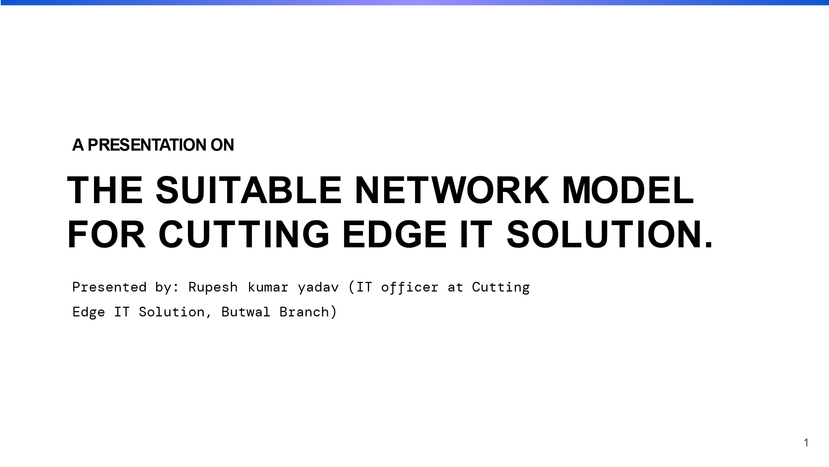

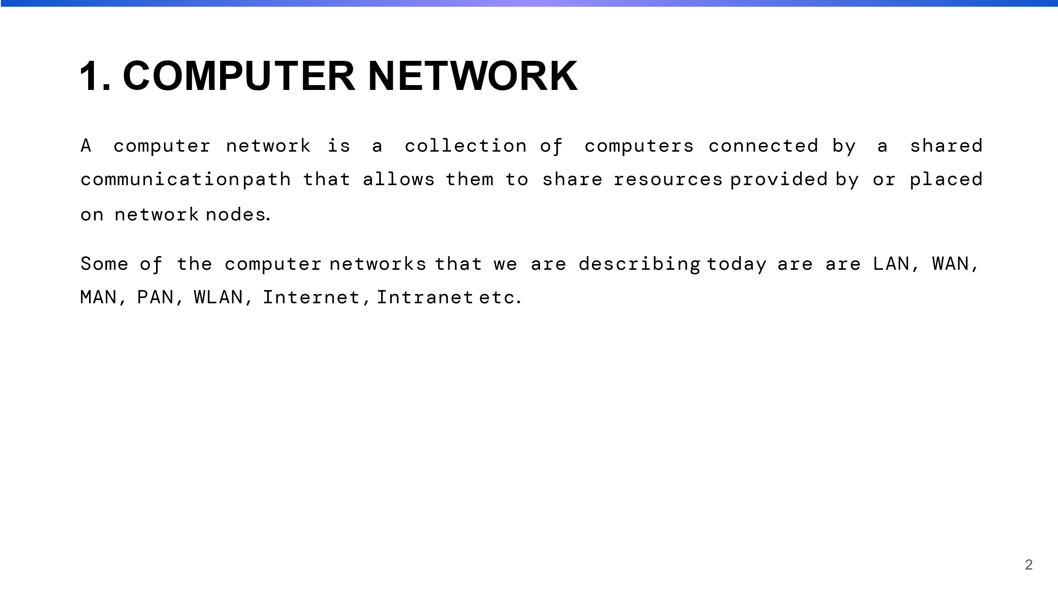

In this section, I discussed computer networks and their various sizes. Actually, a computer network is a collection of computers and other electronic devices that are linked together.

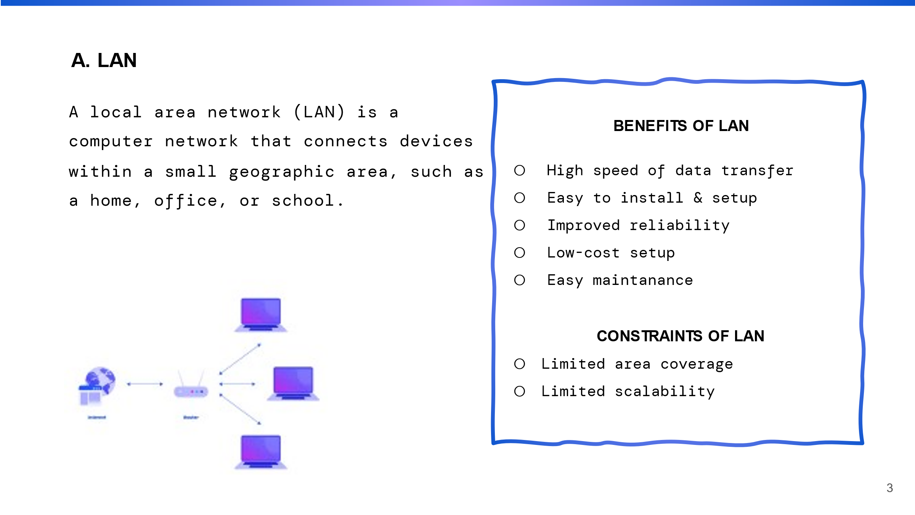

A LAN is a collection of interconnected devices such as a computer, server, printer, and so on. In terms of size, it is a small network. We can see the network, cyber, in the photostudio.

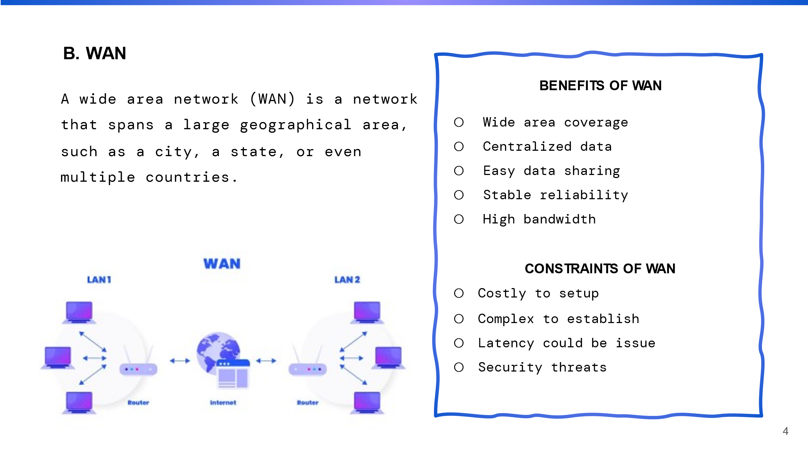

A WAN (wide area network) is a collection of LANs (local area networks) that are linked together. It is a much larger network than a LAN. It covers a large area.

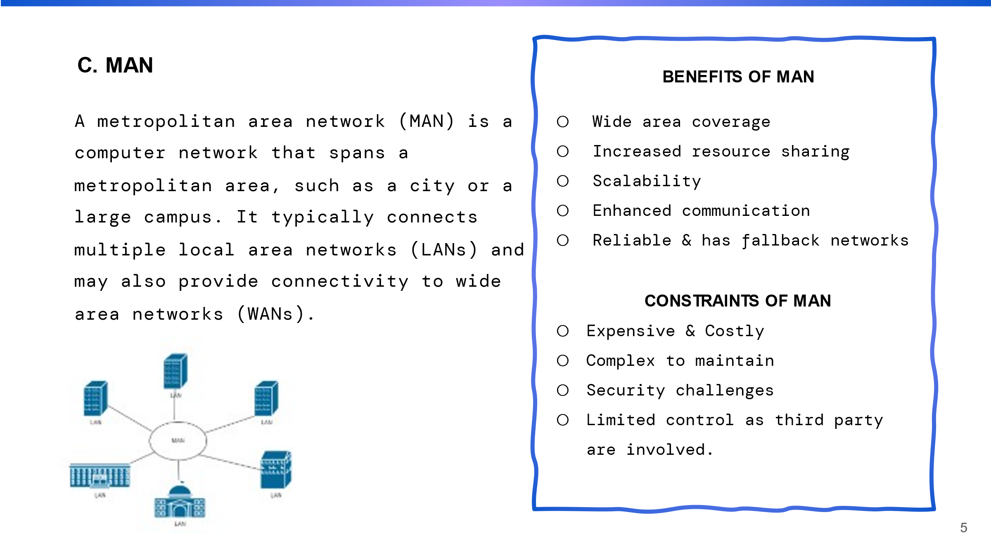

A MAN can be formed by combining multiple LANs and connecting them via high-speed links such as fiber-optic cables or microwave links. It typically spans a region larger than a single LAN but smaller than a Wide Area Network (WAN).

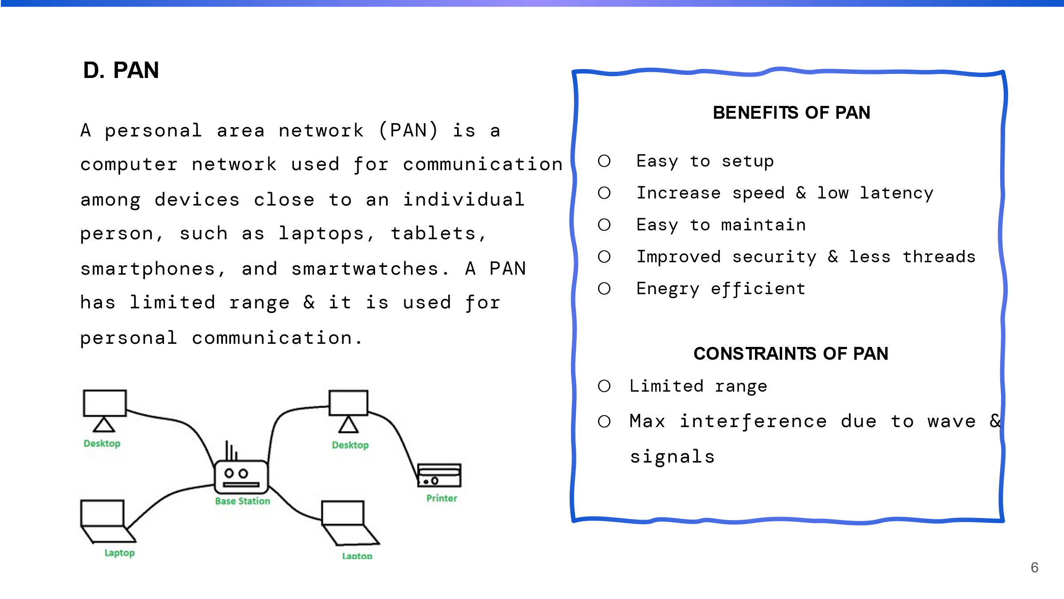

It is a personal network for a single person. A personal area network is created when we connect our laptop to our phone to share data or connect a speaker/earphone to our phone to listen to music (PAN).

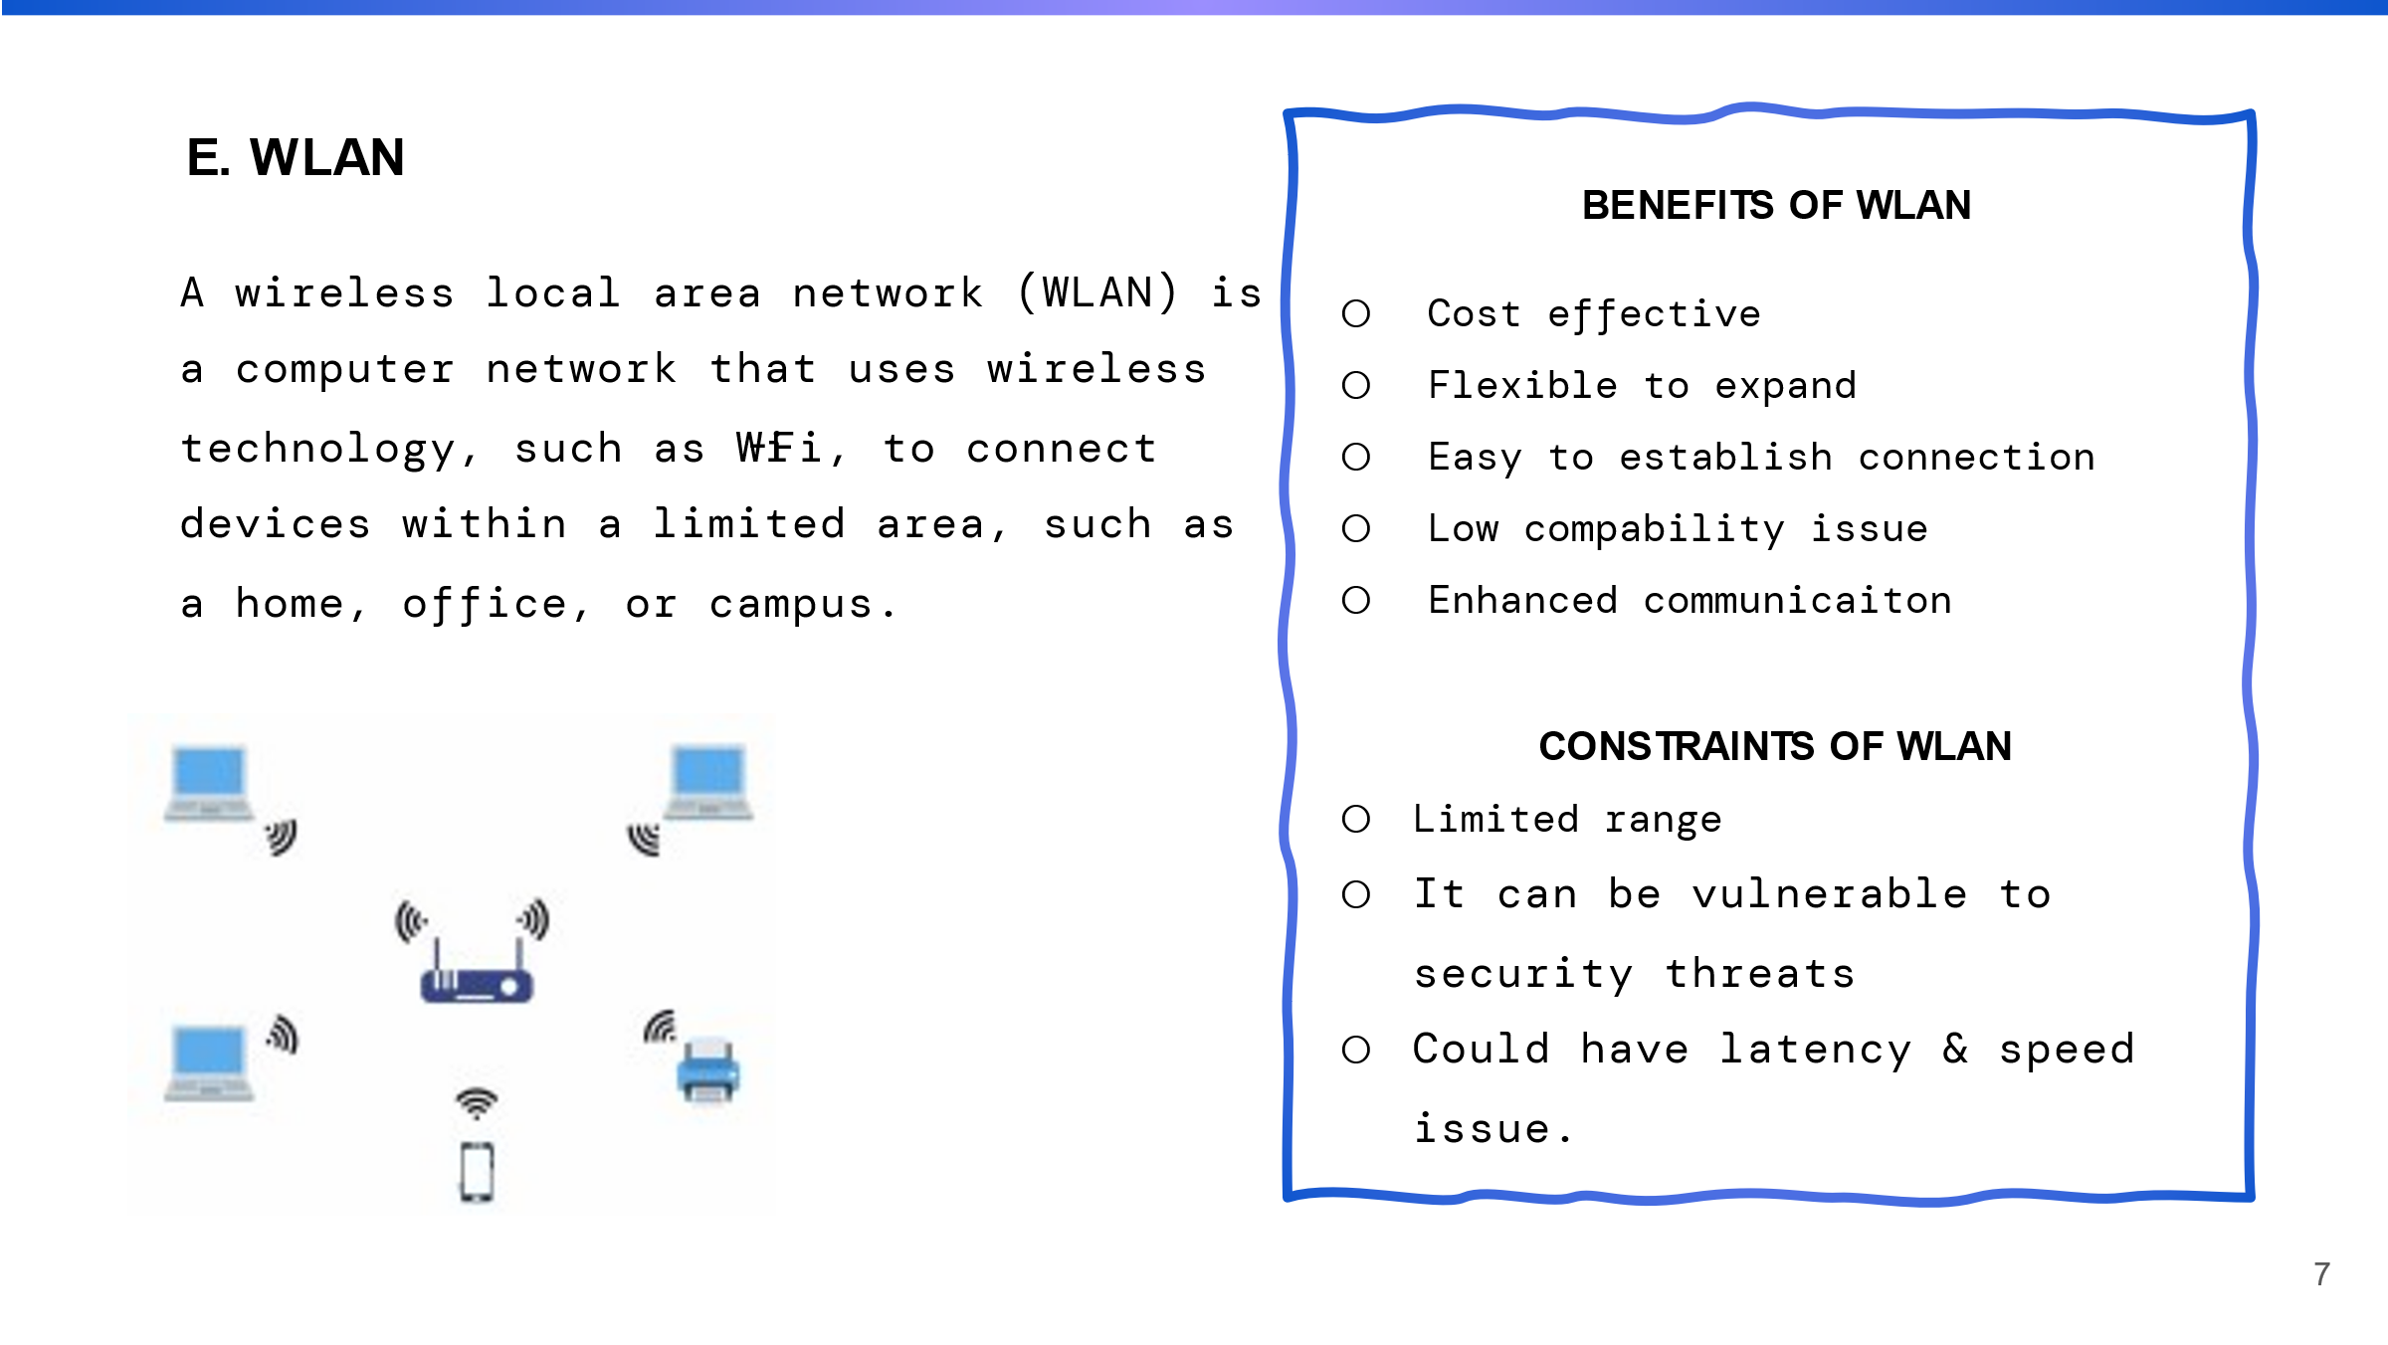

WLAN refers to a type of local area network that makes use of wireless technology. WLANs use radio waves to transmit data between devices, eliminating the need for physical cables to connect them. WLANs can be protected against unauthorized network access by employing various security protocols such as WPA and WPA2.

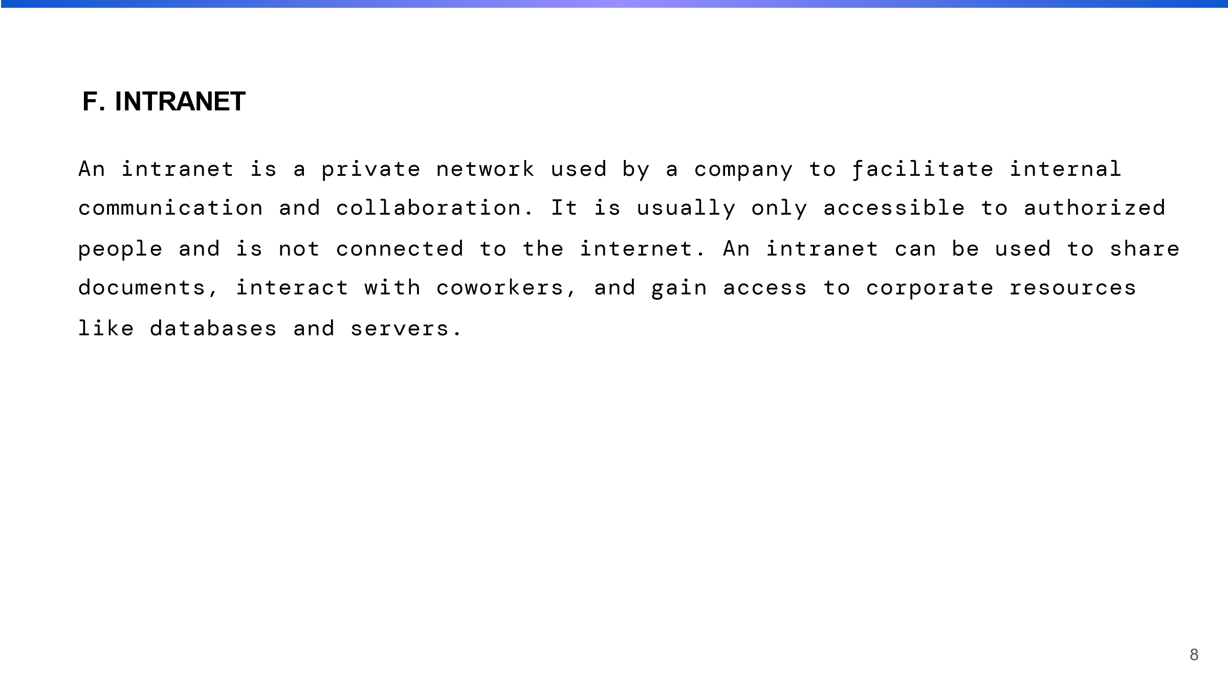

It is similar to the internet in that it uses the same technologies, such as web browsers and servers, but it is only accessible to authorized users within the organization. It is typically used to share company documents, news, and information with employees.

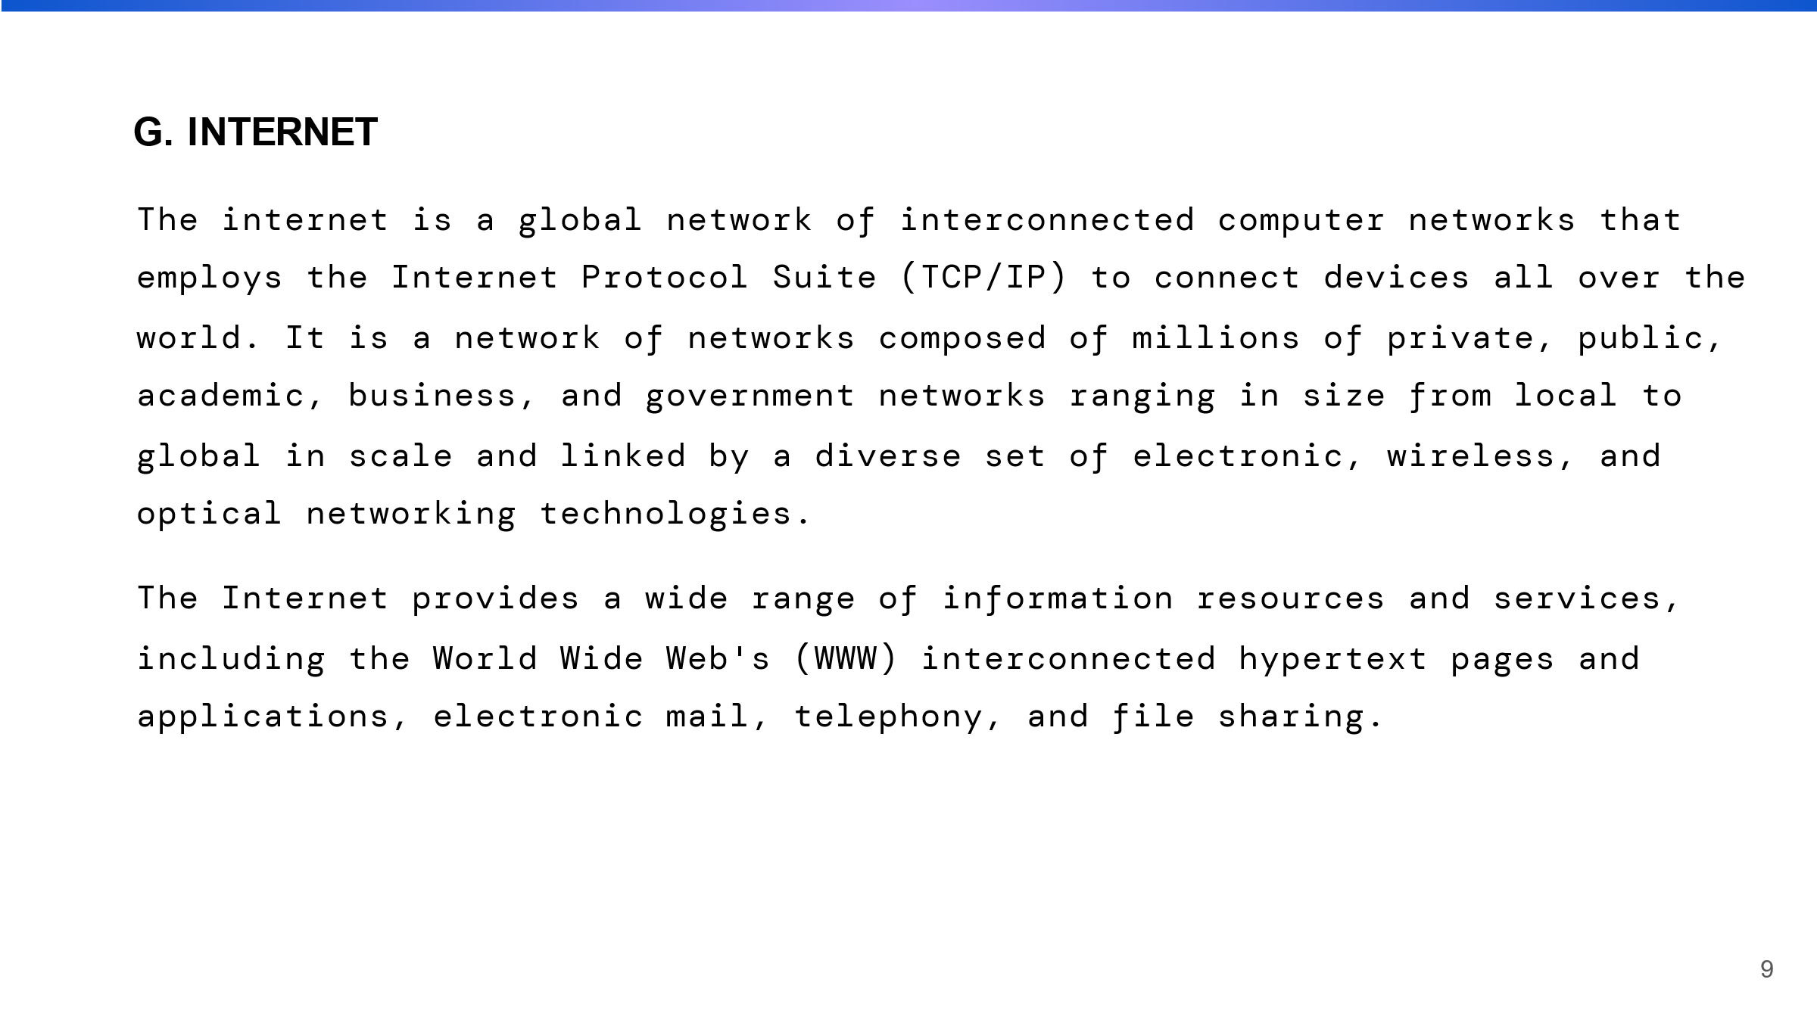

It is a global network comprised of numerous interconnected networks such as Local Area Networks (LANs), Wide Area Networks (WANs), and Metropolitan Area Networks (MANs) (MANs). This network was linked together using a variety of technologies, including fiber-optic cables, satellite links, and microwave connections.

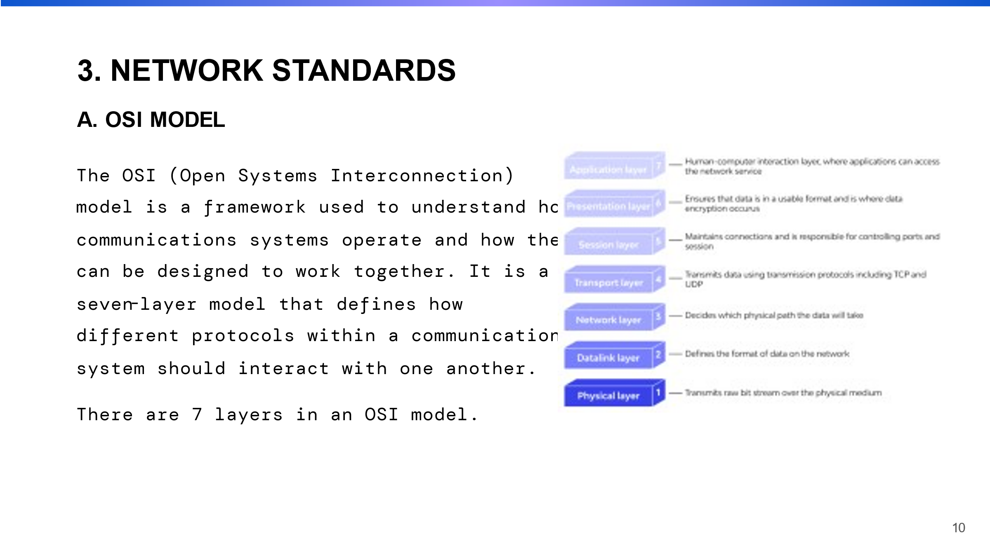

**NETWORK STANDARDS**

I talked about network standards and models here. Network standards are technical guidelines and specifications that govern how different networking devices and systems should interact with one another.

**OSI MODEL**

It is a framework, it have 7 layer and each layer performs a specific function in the process of transmitting data.

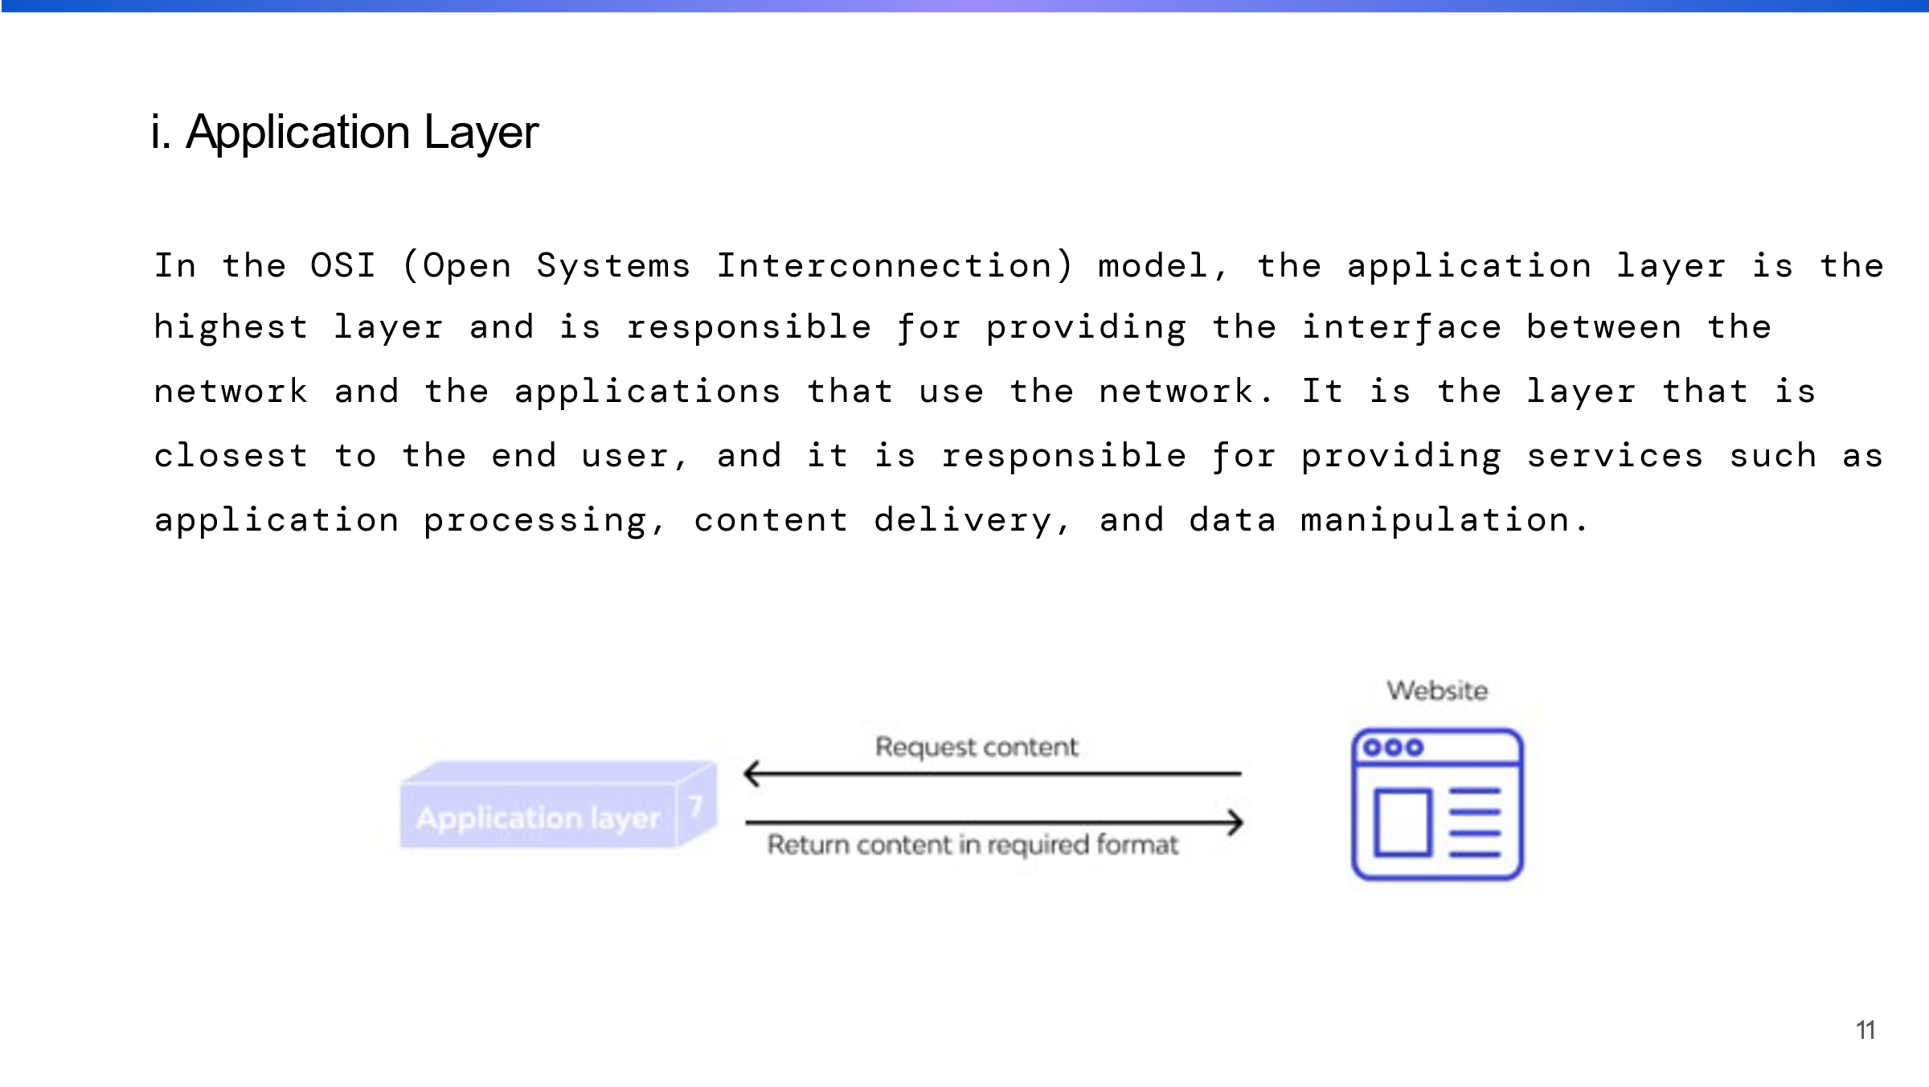

This is the upper layer of the OSI model on behalf of the sender and the bottom layer on behalf of the receiver. This layer is in charge of providing user services such as email and file transfer.

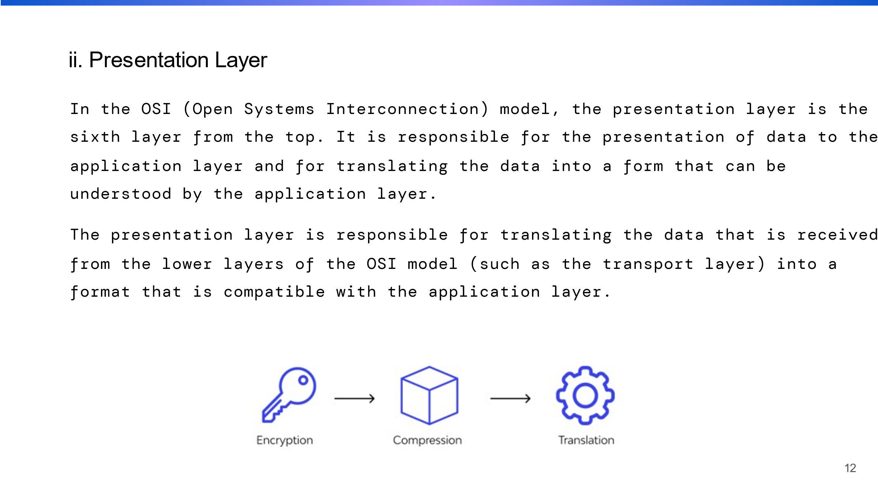 This is second layer of OSI model on the behalf of sender. This layer is responsible for translating data between different formats, such as by converting between ASCII and EBCDIC.

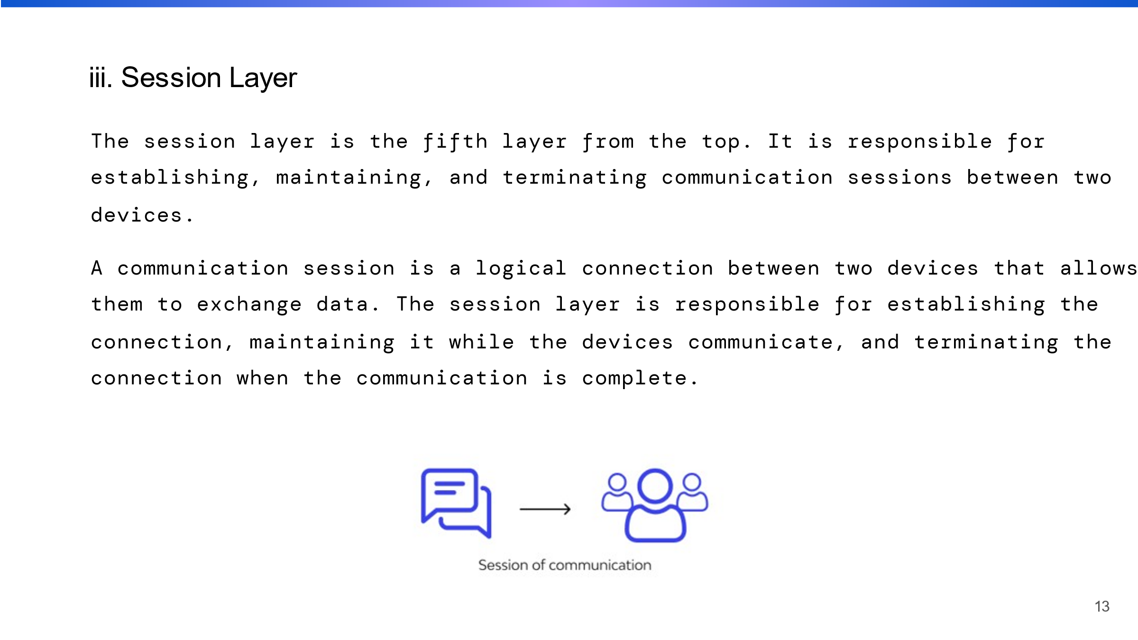

This is the third layer of the OSI model on behalf of the sender. It is in charge of creating, maintaining, and terminating connections between applications on various devices.

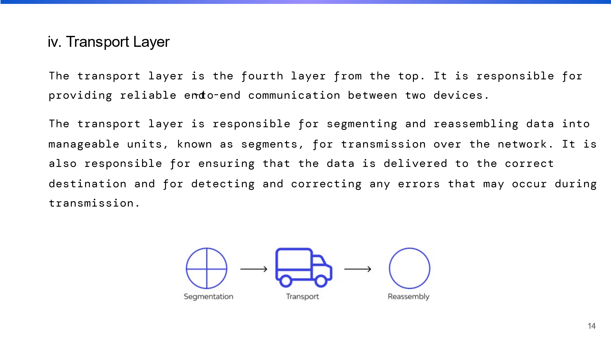

This is the fourth layer of the OSI model and is responsible for ensuring that data is delivered reliably, such as by retransmitting lost data packets, on behalf of the sender.

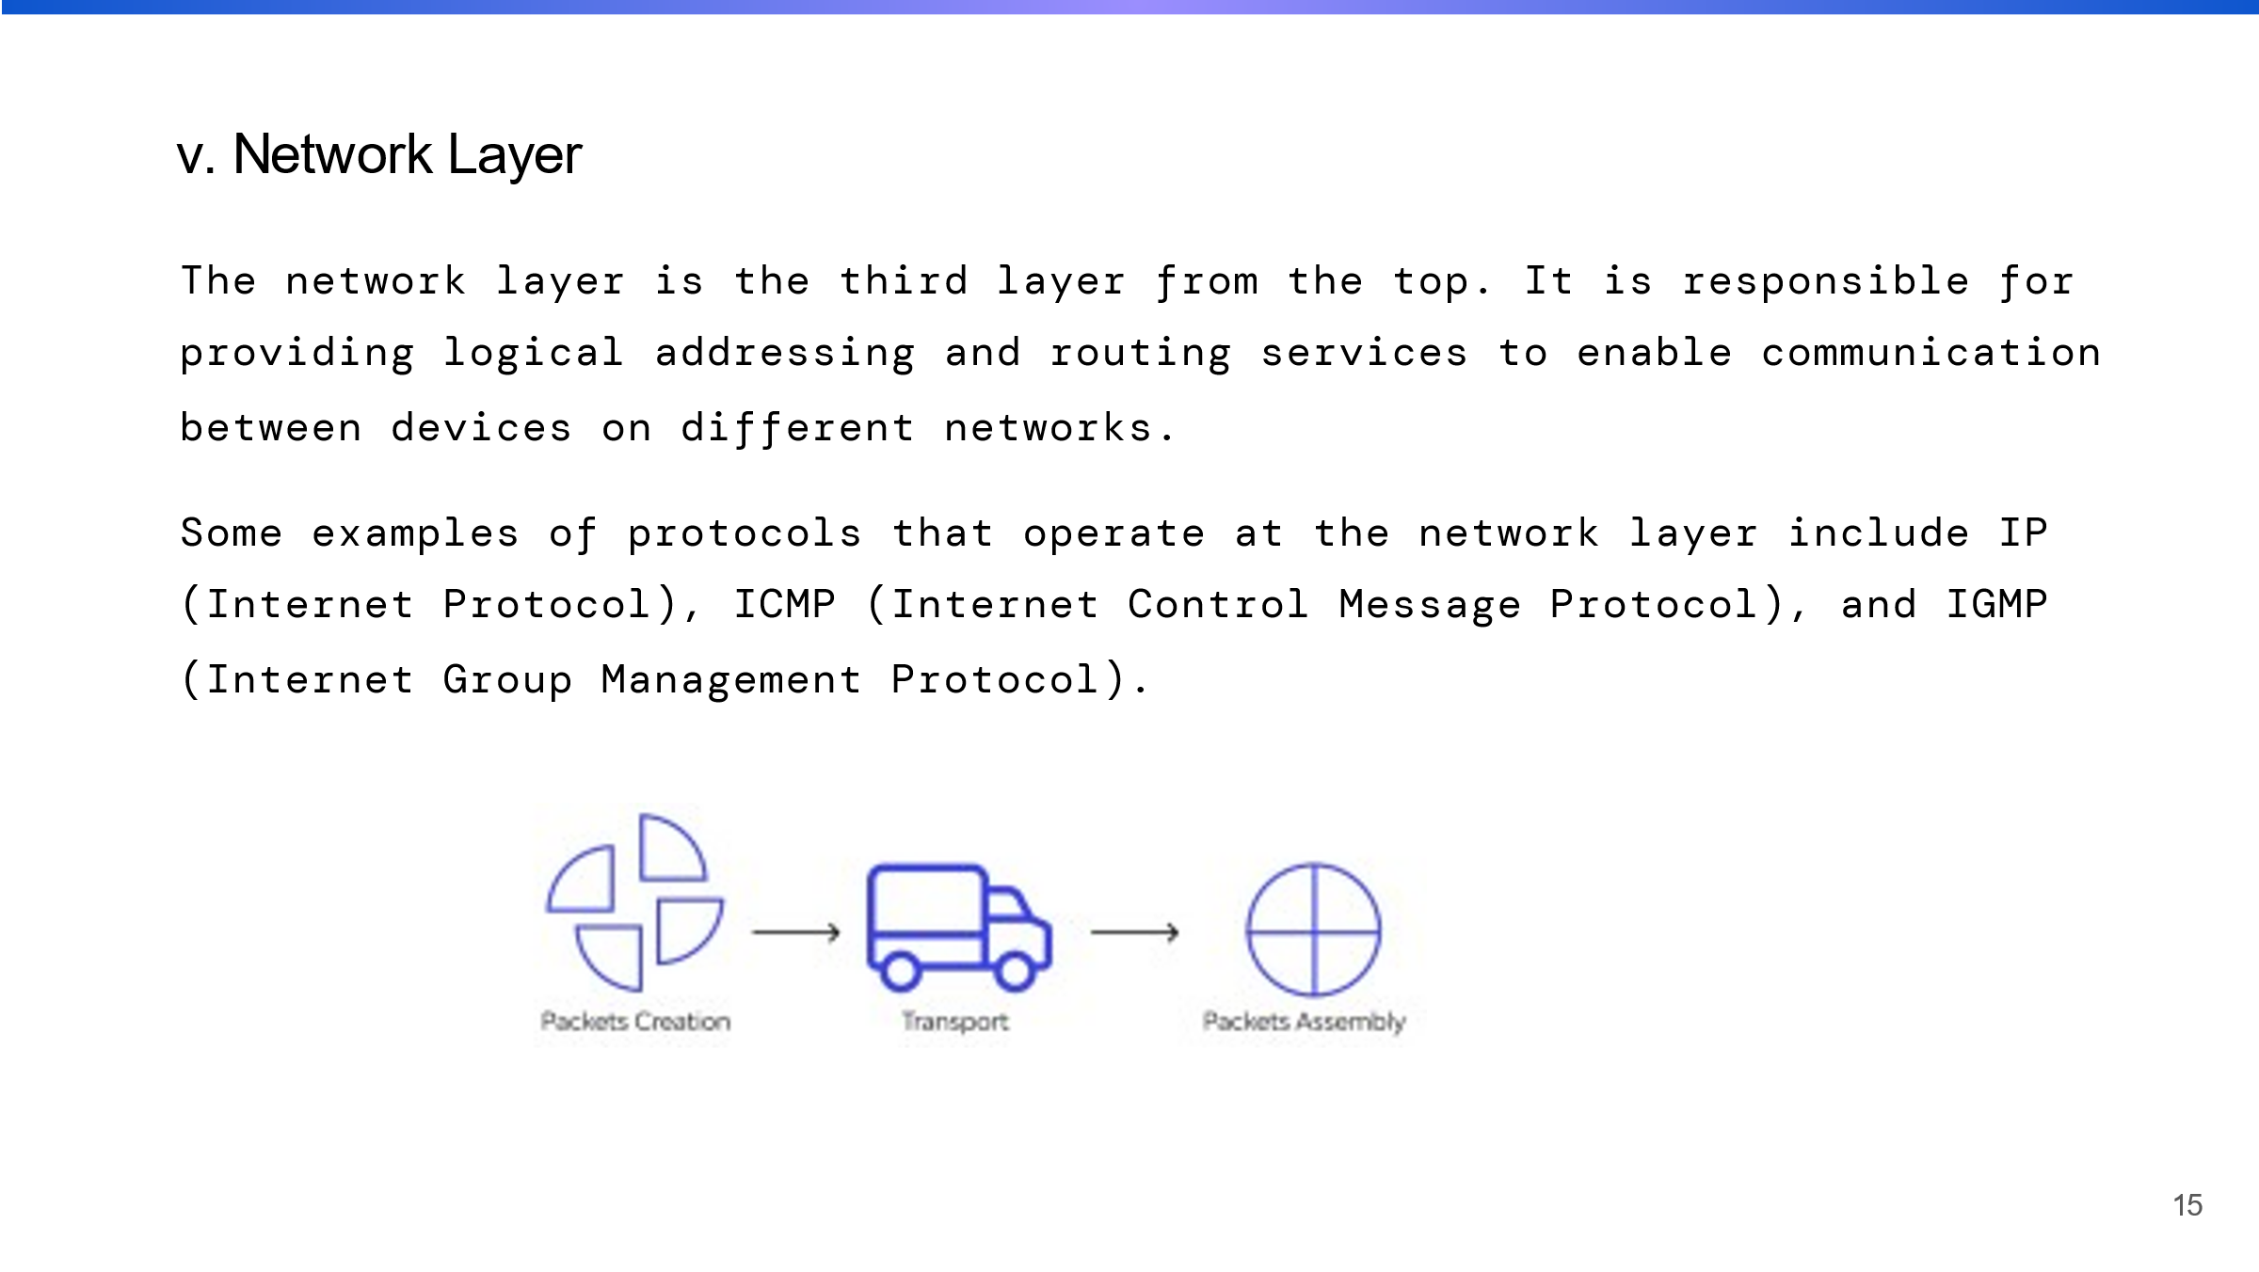

This is the fifth layer of the OSI model and is responsible for routing data between different networks, such as determining the best path for data to take.

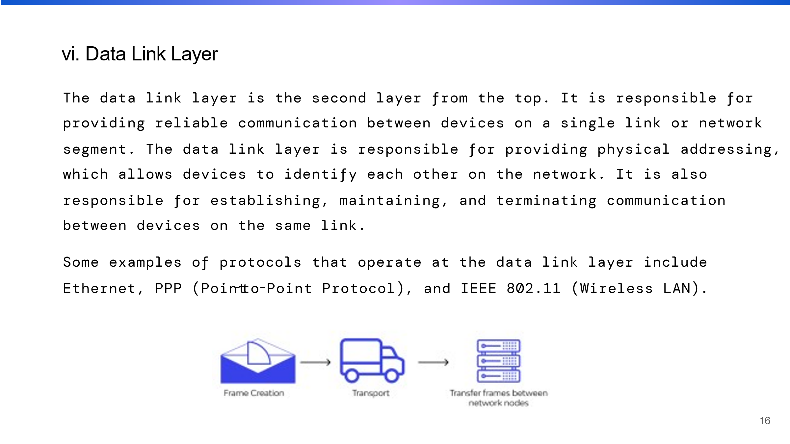

This is the sixth layer of the OSI model, and it is in charge of creating a reliable link between devices, such as by adding error detection and correction codes.

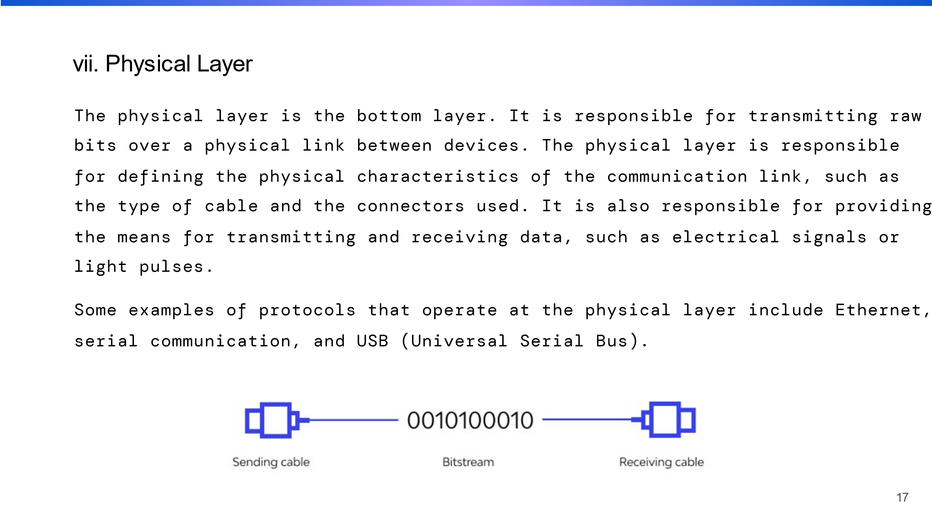

This is the final or seventh layer of the OSI model on behalf of the sender and the first layer of the receiver, and it deals with the physical connection between devices, such as cables, connectors, and signal voltage levels.

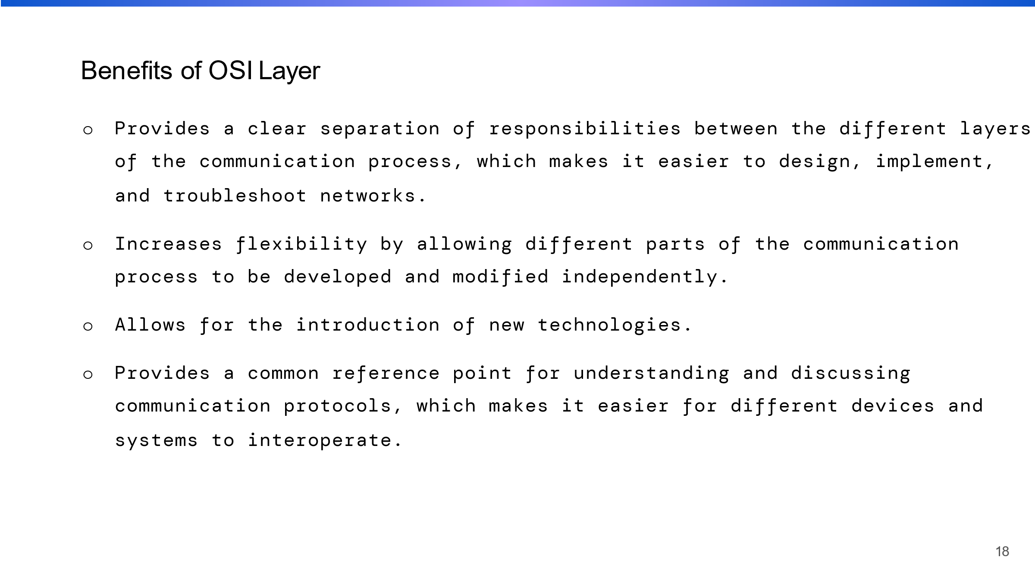

Here, I discussed about benefits of OSI layer what the benefits we will get in OSI model.

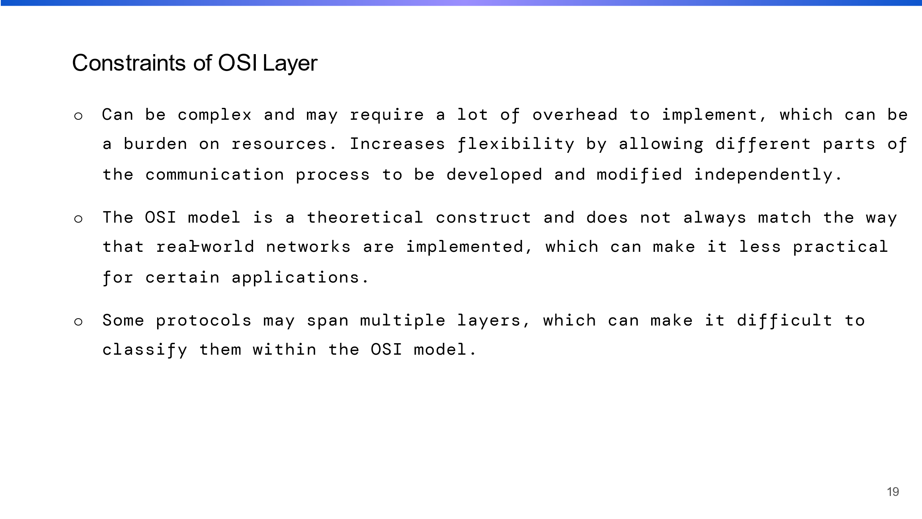

Here, I discussed about constraints of OSI layer what the constraints we will get in OSI model.

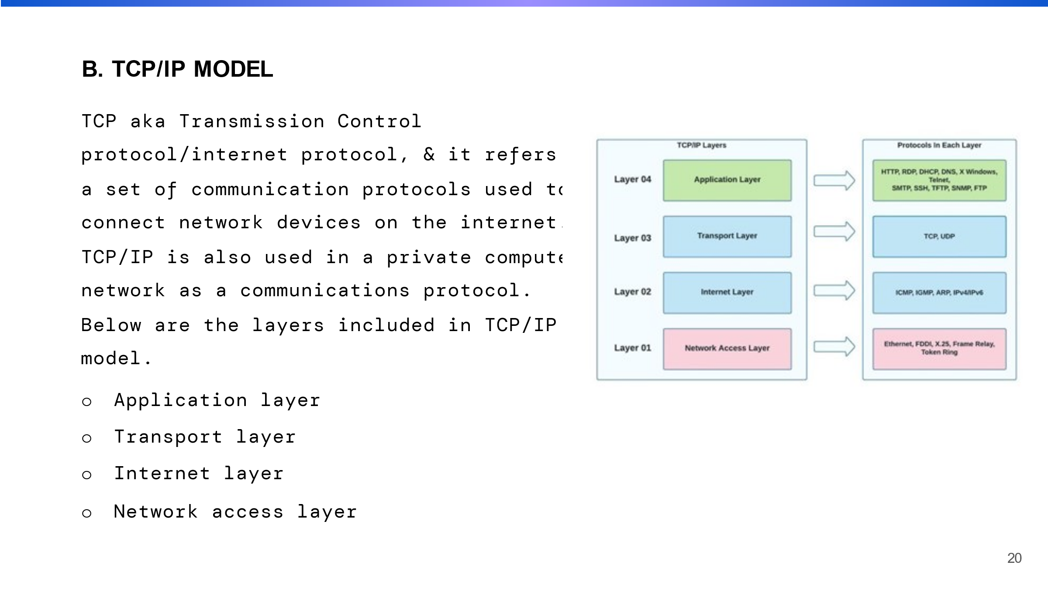

I talked about the TCP/IP model, which is the foundation of the internet and most other networks. It is widely used due to its ease of use and compatibility with a wide range of networking technologies and devices.

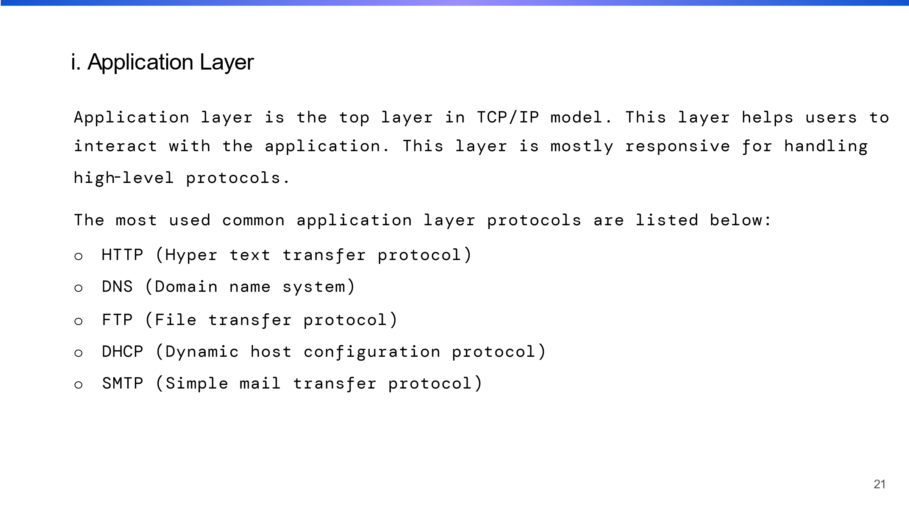

This is the highest layer or first layer of the TCP/IP model on behalf of the sender, and it corresponds to the OSI model's session, presentation, and application layers. It provides a unified interface for users to access network services such as email, file transfer, and web browsing.

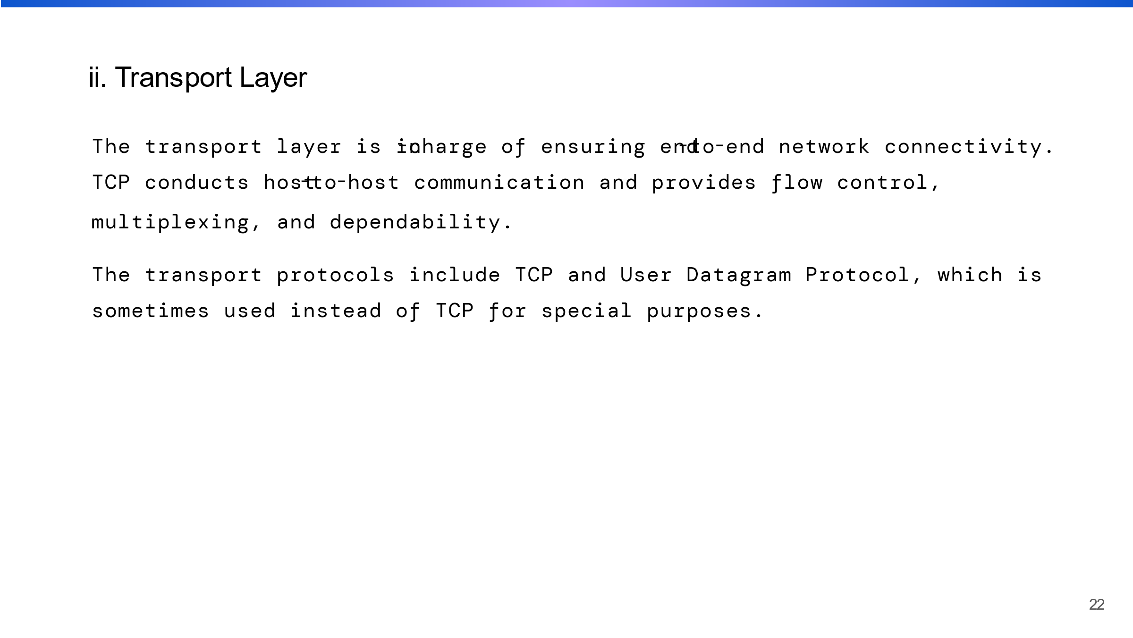

This is the second layer of the TCP/IP model on behalf of the sender, and it is responsible for ensuring that data is delivered reliably. It corresponds to the OSI model's transport layer.

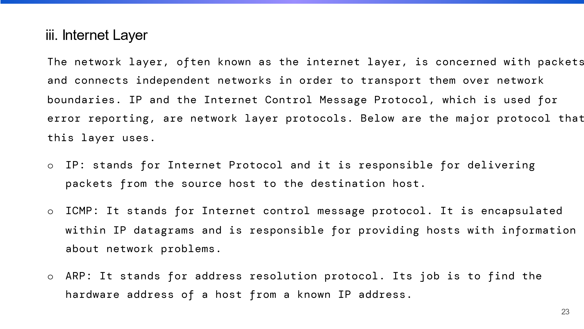

This is the third layer of the TCP/IP model that is responsible for routing data between different networks on behalf of the sender. It corresponds to the OSI model's network layer.

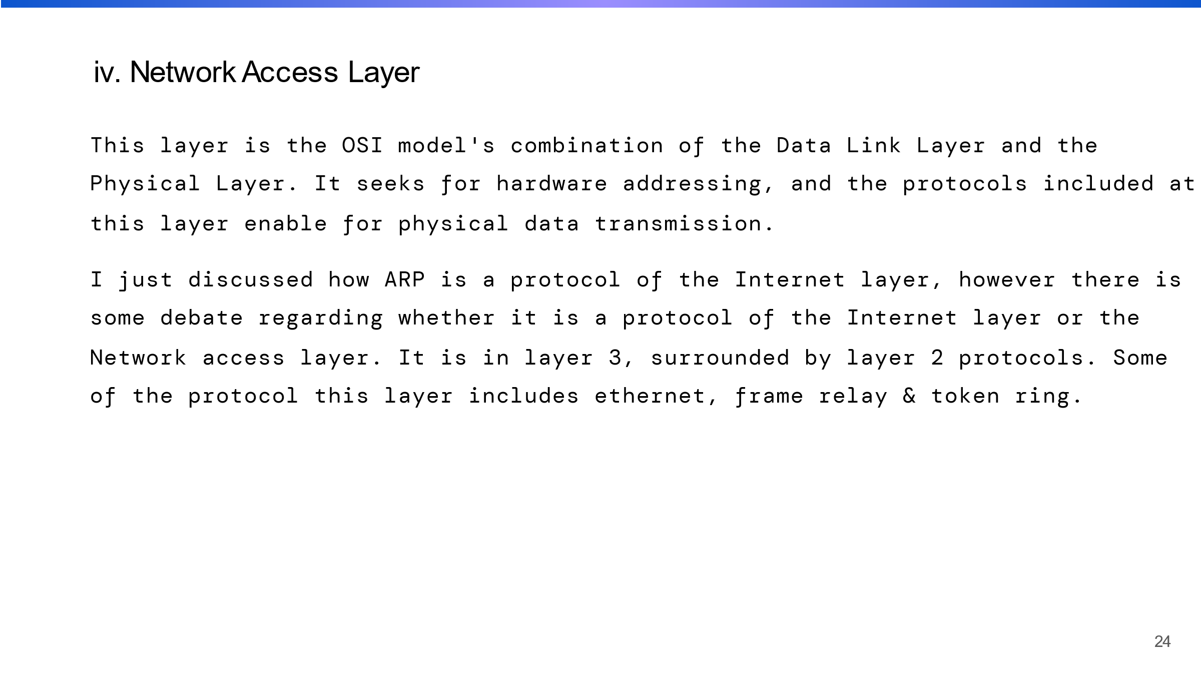

This is the fourth layer of the TCP/IP model on behalf of the sender, and the first layer of the TCP/IP layer on behalf of the receiver. It corresponds to the OSI model's physical and data link layers.

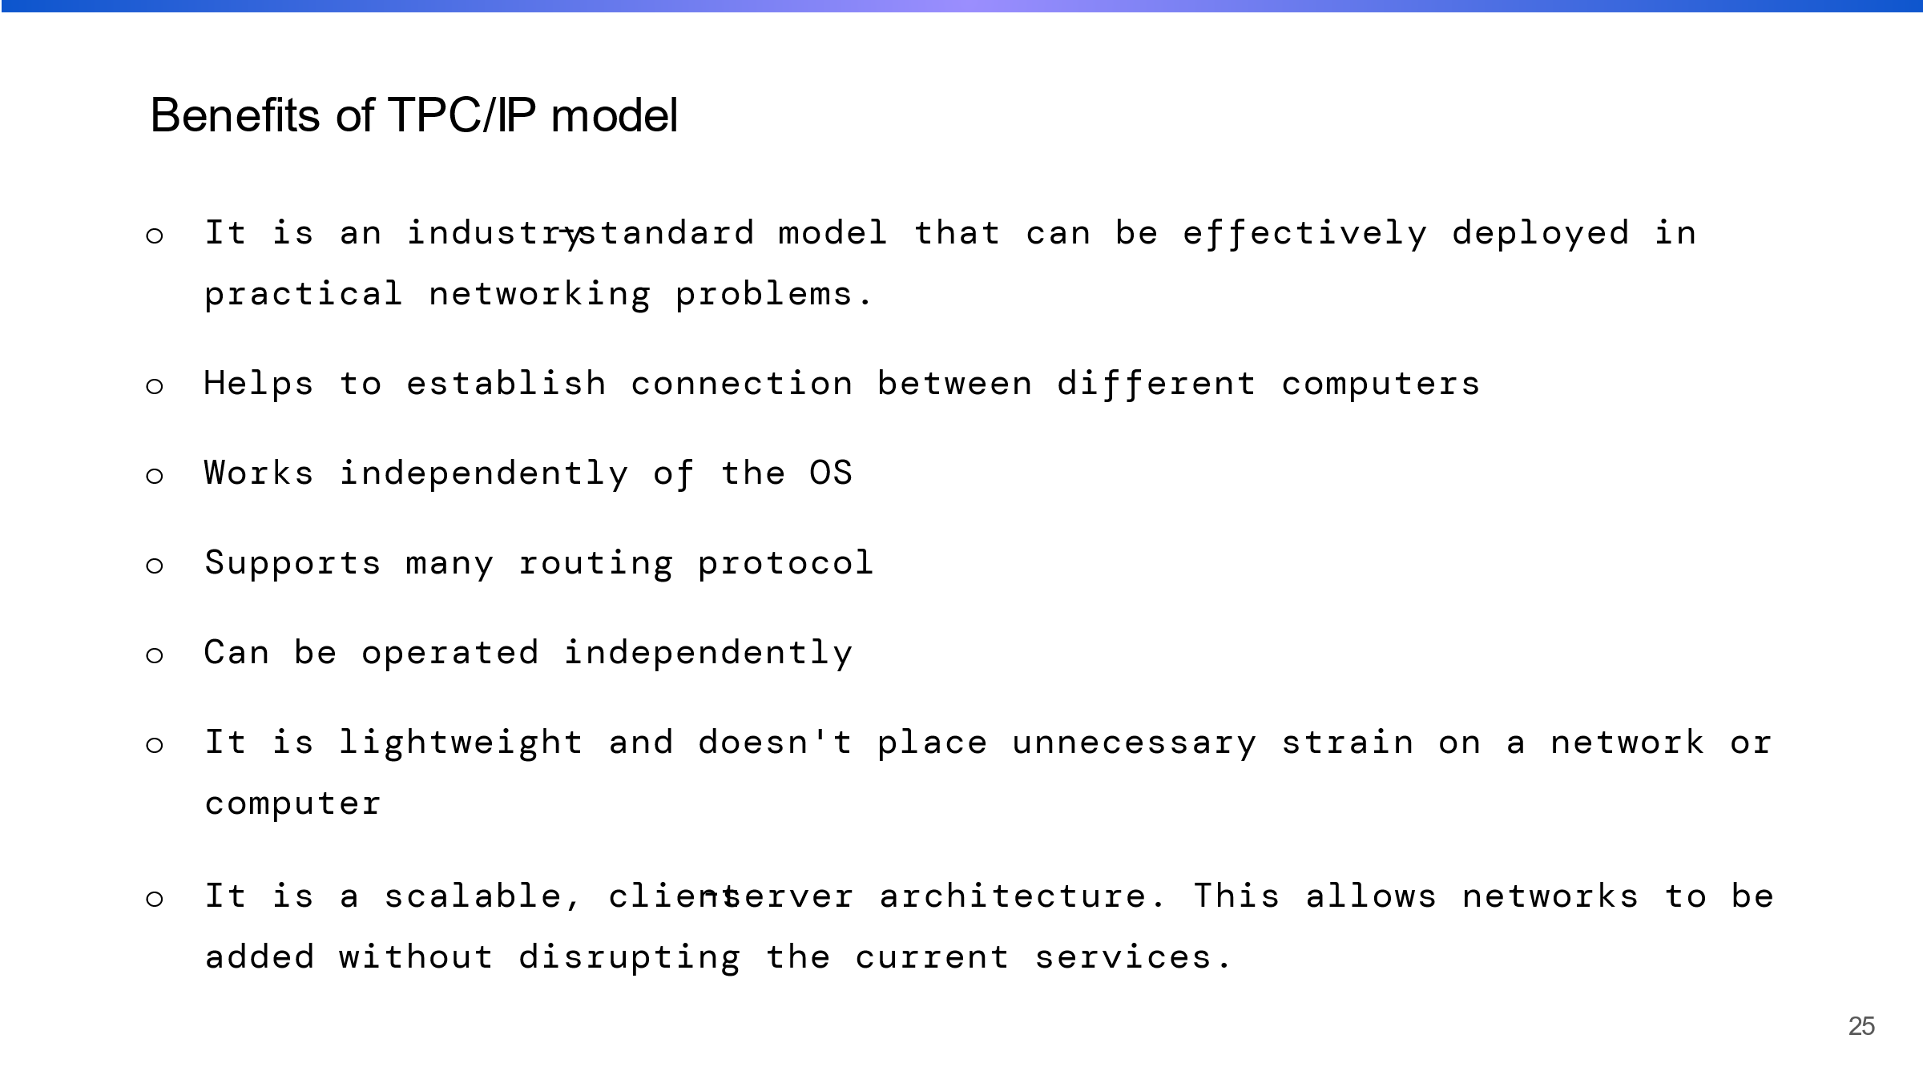

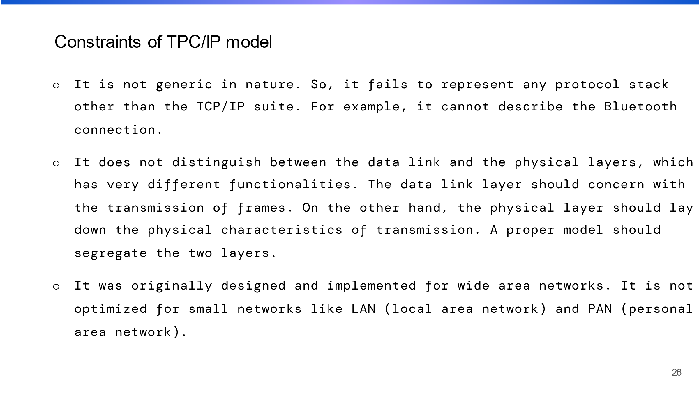

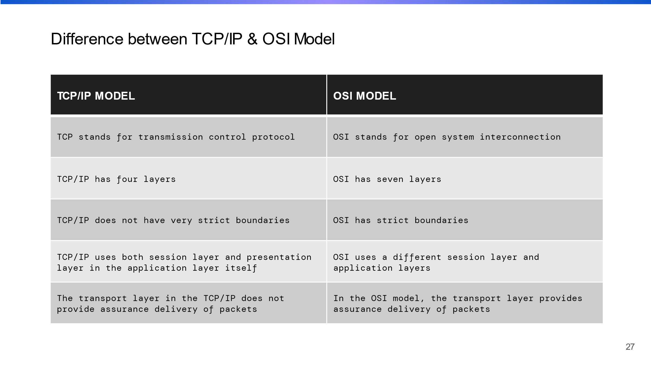

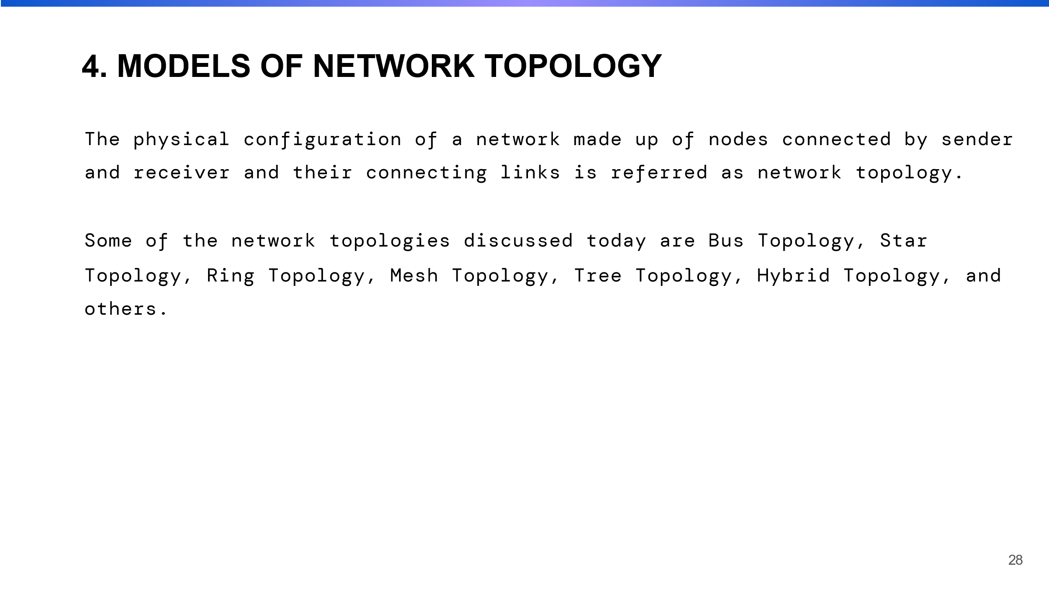

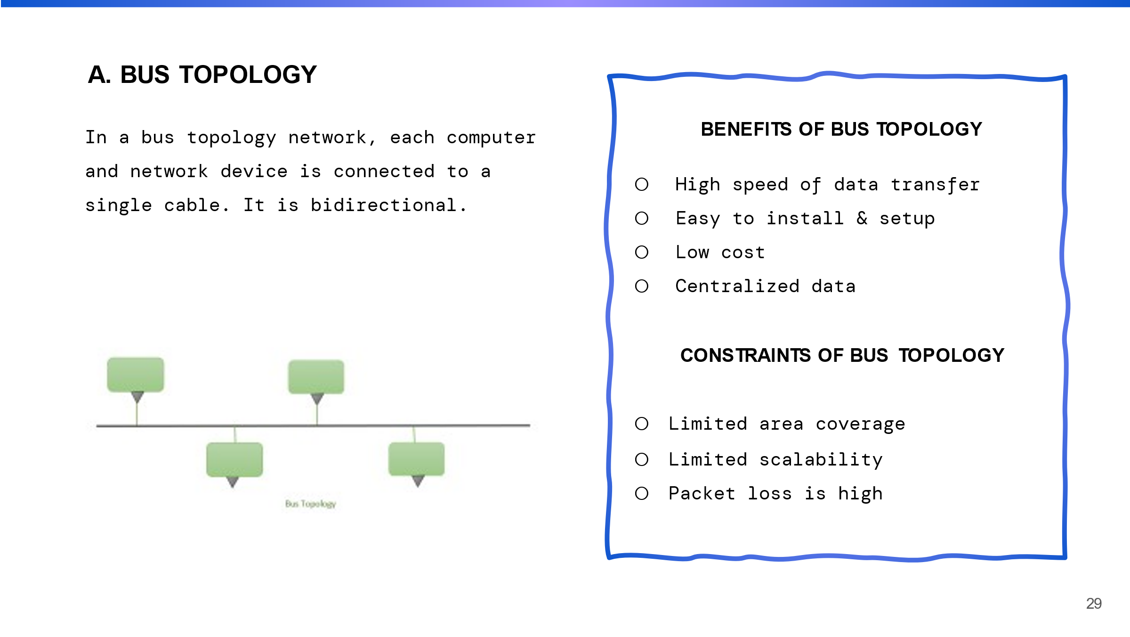

I talked about bus topology here. It is easy to implement and inexpensive, but it is less reliable than other topologies.

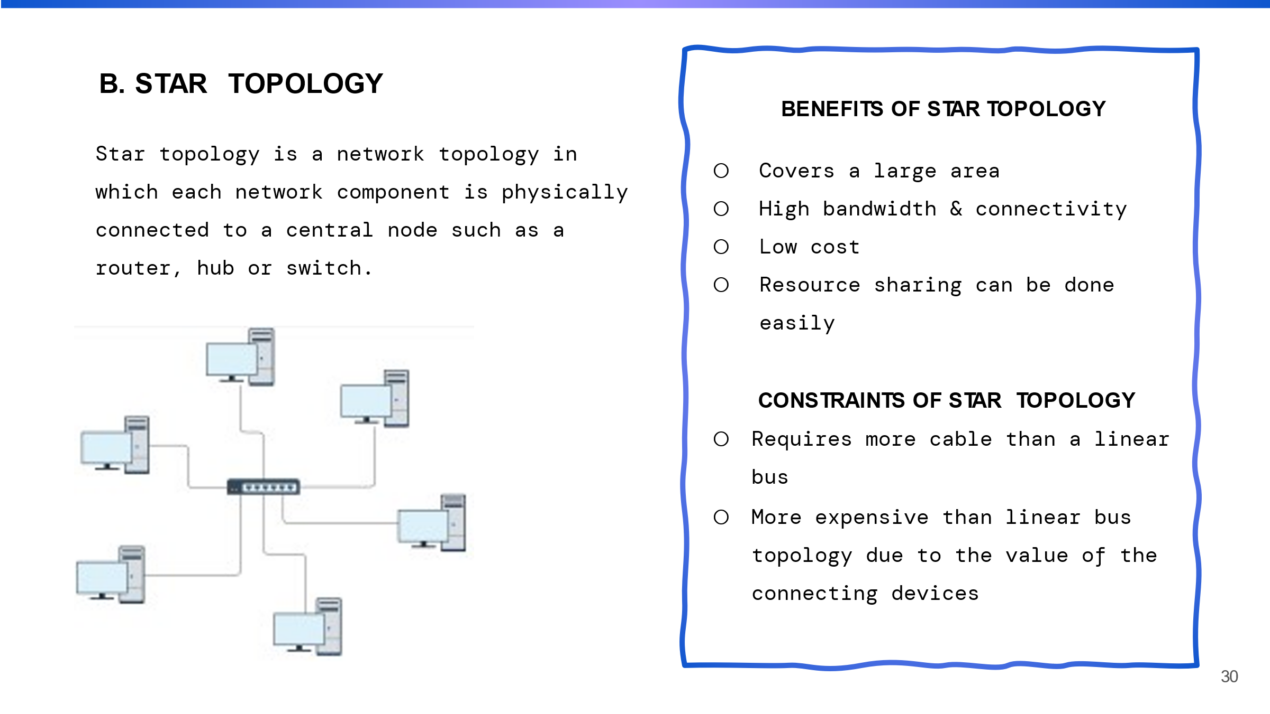

Because the failure of a single link affects only one device rather than the entire network, the star topology is more reliable than the bus topology. It is also easier to connect and disconnect network devices because they only need to be connected to or disconnected from the central hub.

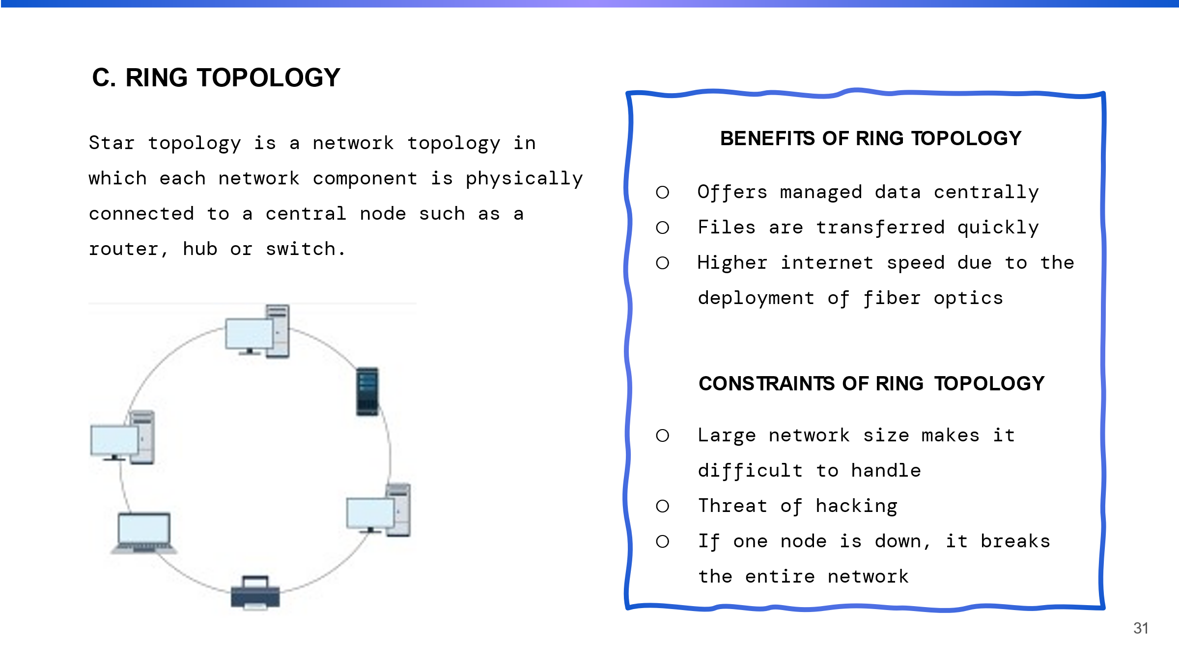

In this topology all the device are connected to one another in a close loop, this topology looks like ring. It is more reliable than the bus topology, as failure of a single link it will affect only two devices.

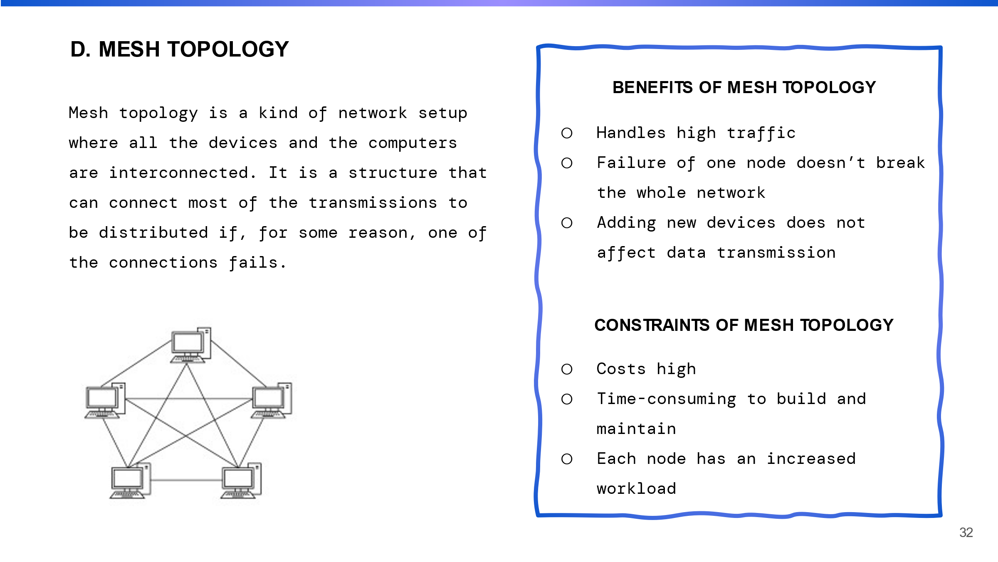

This topology provides the high level of reliability and redundancy and Most complex for infrastructure and management. Mostly this topology are used by military, and emergency service networks.

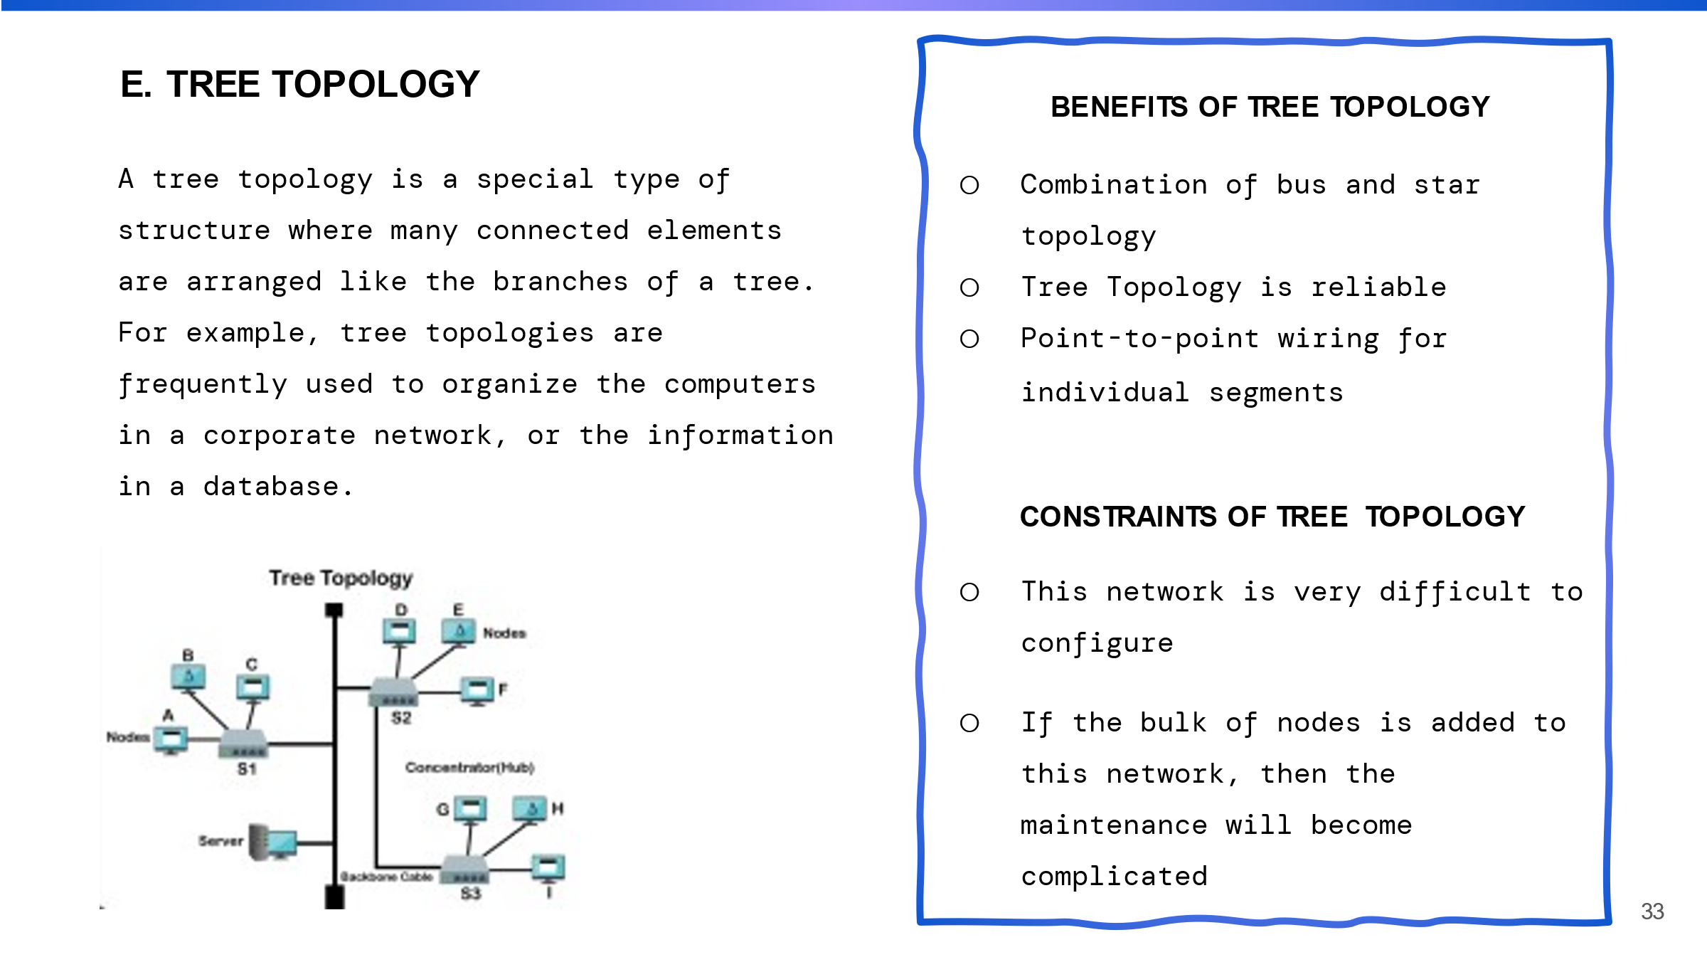

This topology looks like the root of the tree. This topology is used in large enterprise networks and in wide area network configuration.

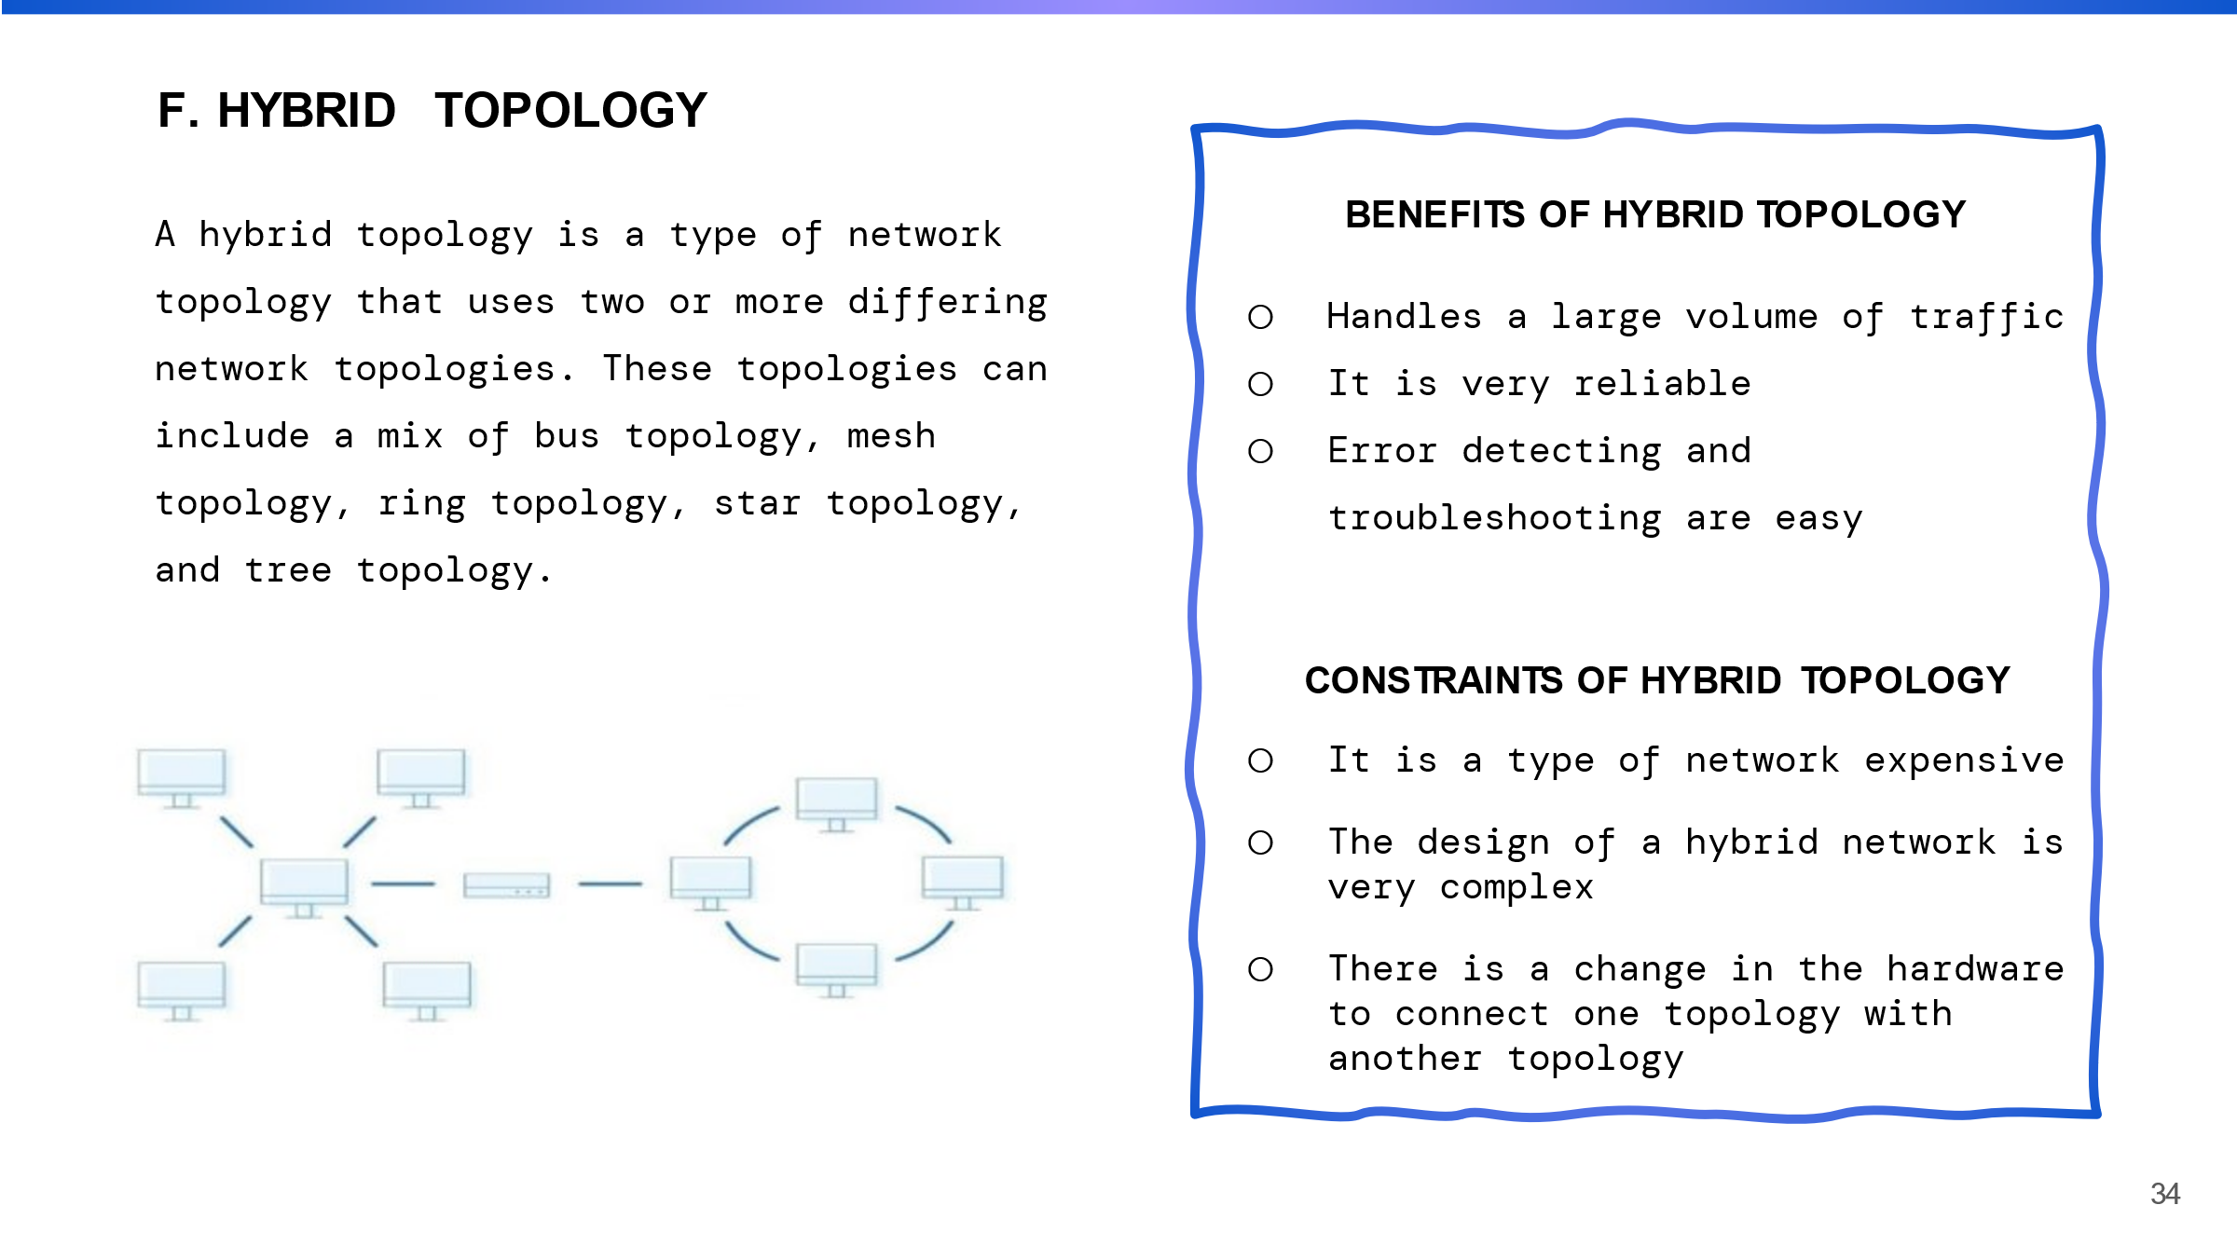

Hybrid topology is group of topology that connected together, mostly used to connect different types of networks, such as LANs and WANs and it provides a scalable and flexible solution for large and complex networks.

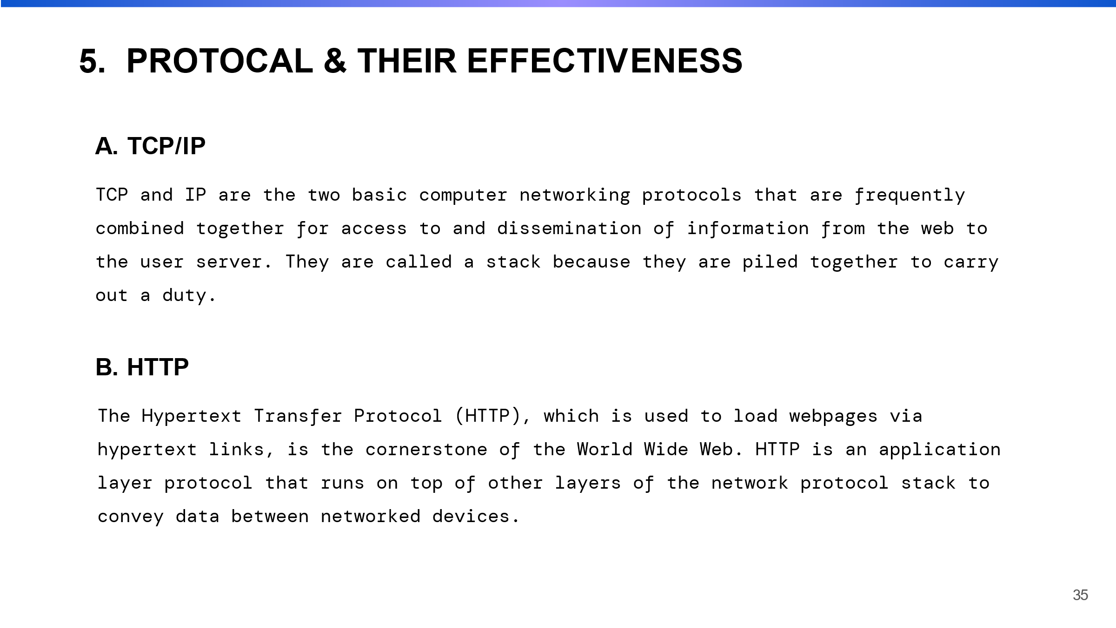

Here I discussed about protocol actually protocol defines the format, time, sequence and error checking of data transmission. It provides different types of service of such as file transfer, Email, and web browsing.

**TCP/IP**

It is the primary protocol and mostly used on the internet, LANs, WANs, and other networks. IP portion of TCP/IP is responsible for routing data packets across different networks and devices and use to identify the IP address of each packet.

**HTTP**

This protocol operates on the client-server model and sends a request to a server ,and the server responds the requested information.

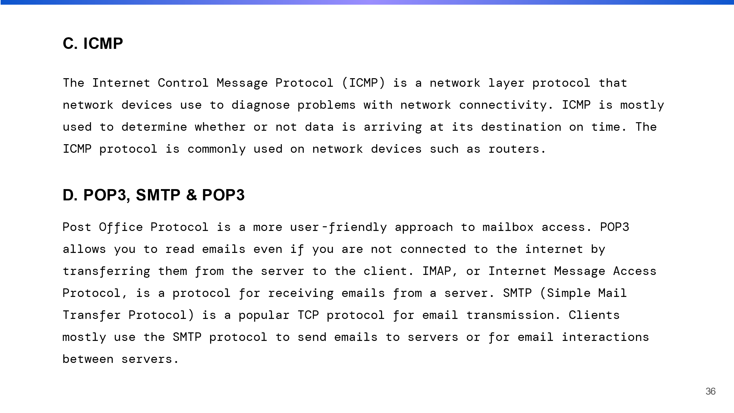

**ICMP**

It is an integral part of IP and it provides the necessary feedback for error reporting and network troubleshooting

**POP3, SMTP &POP3**

This protocol is mainly used to provide a complete E-mail system where POP3 used for receiving E-mail and SMPT is used to send the E-mail.

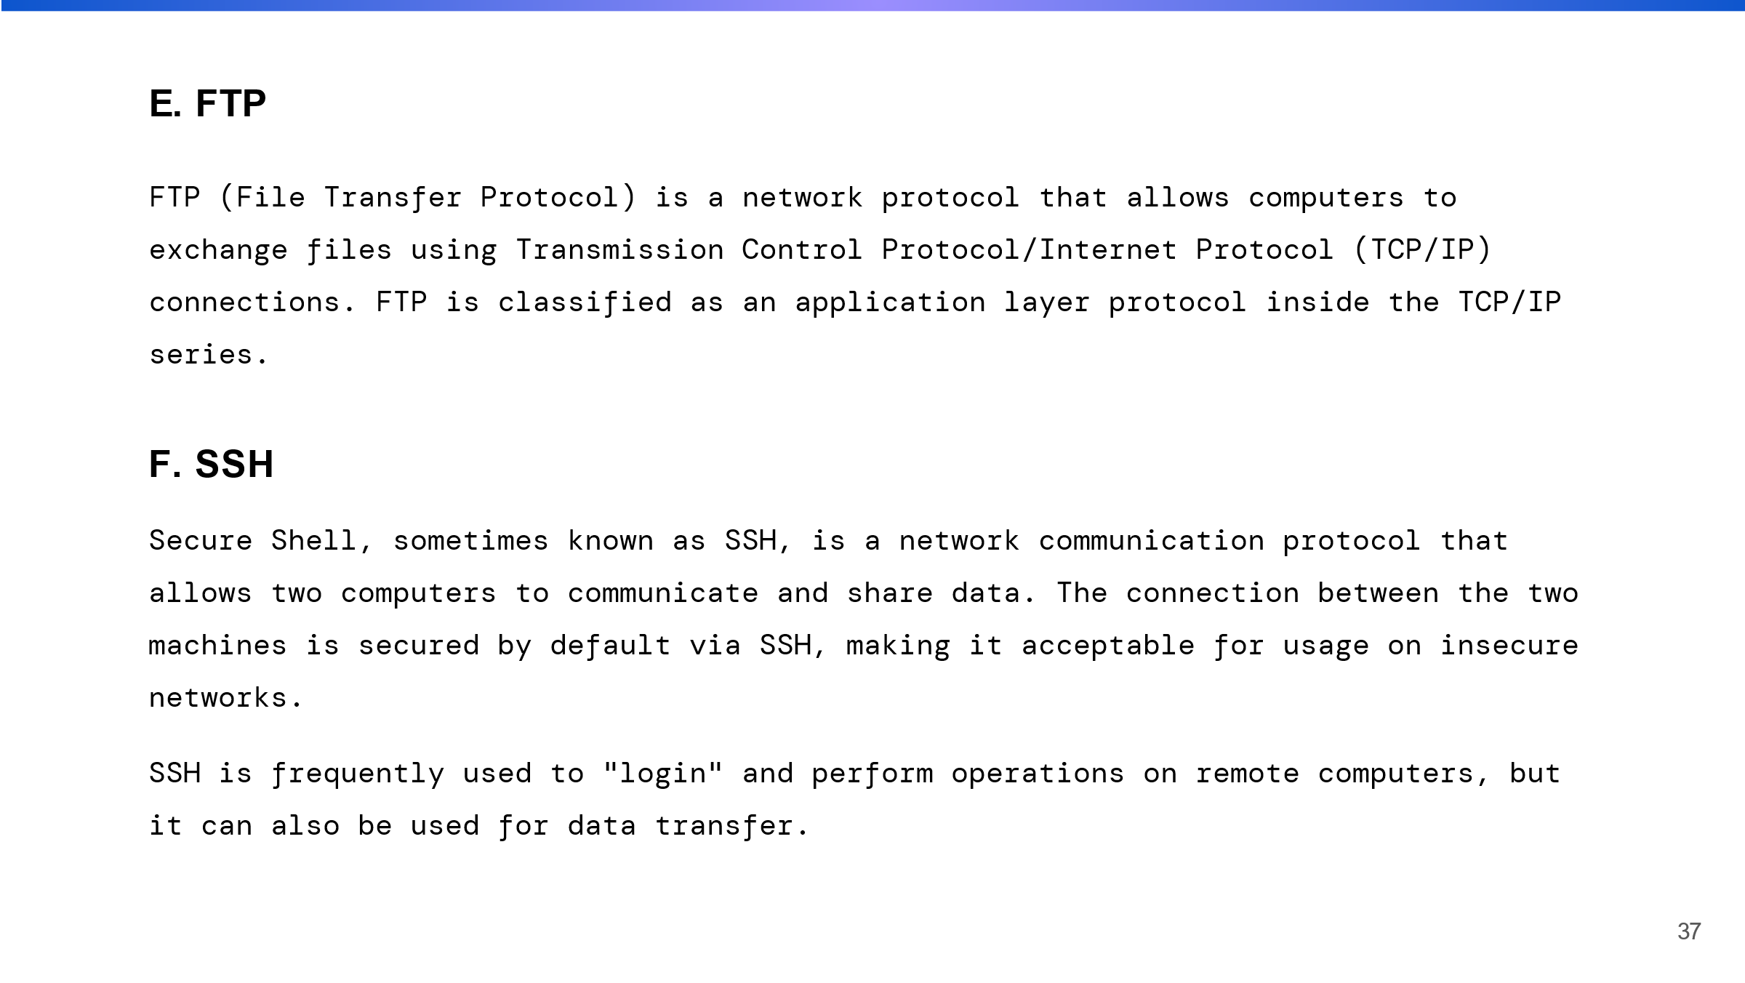

FTP

This layer is widely used for transferring files over the internet. It have security vulnerabilities.

SSH

It is widely used in various fields such as cloud computing, network administration and DevOps among others. It encrypts all network data, including passwords, making it far more secure than previous remote login protocols like Telnet, which send data in cleartext.

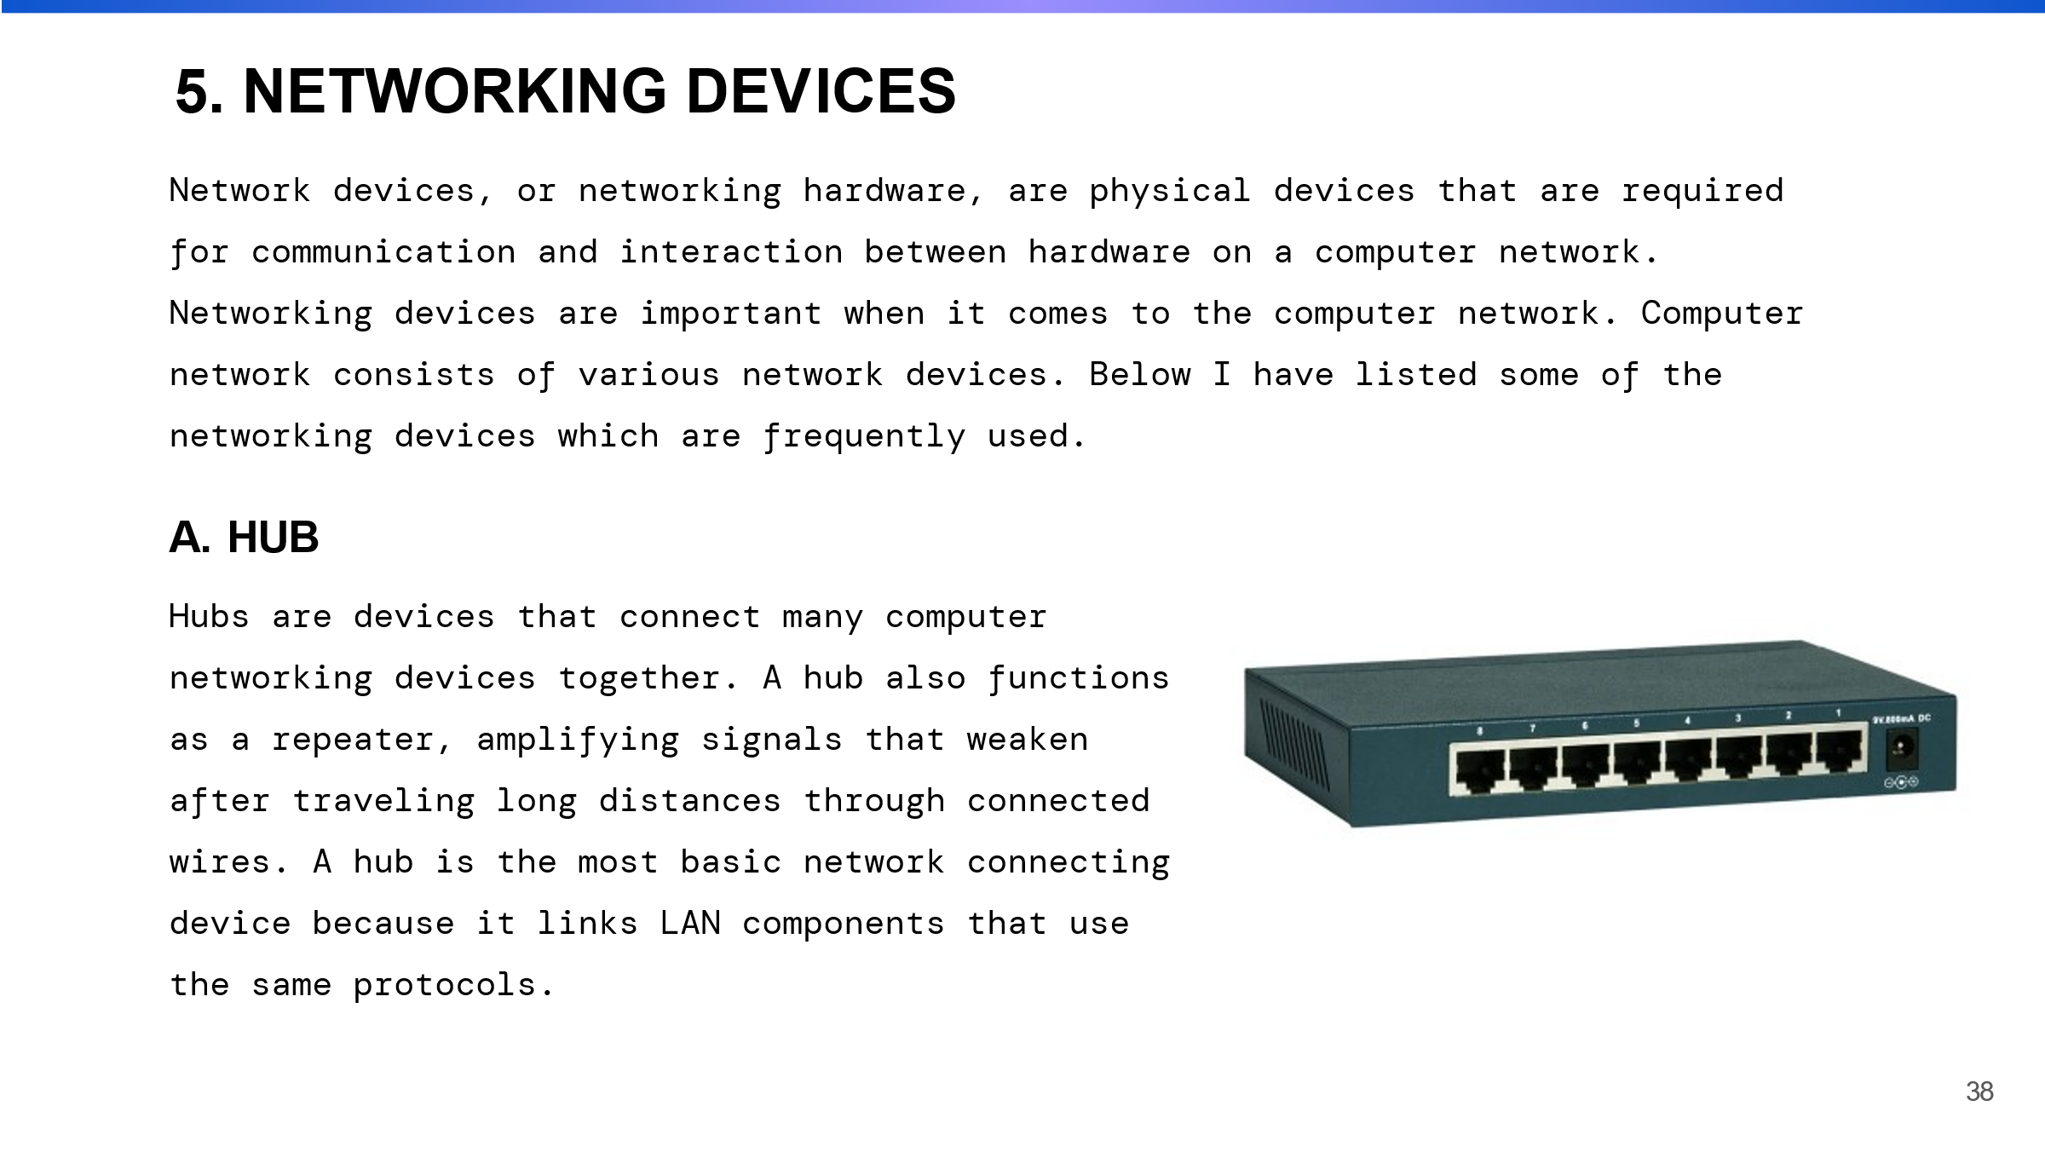

Here I discussed about networking device and explained some list of device that is frequently used. Networking device is used to connect the two or more device together or used to make a network.

HUB

A hub is a simple device that connects multiple network devices but does not route data packets between them. Instead, it broadcasts the data to all devices that are connected.

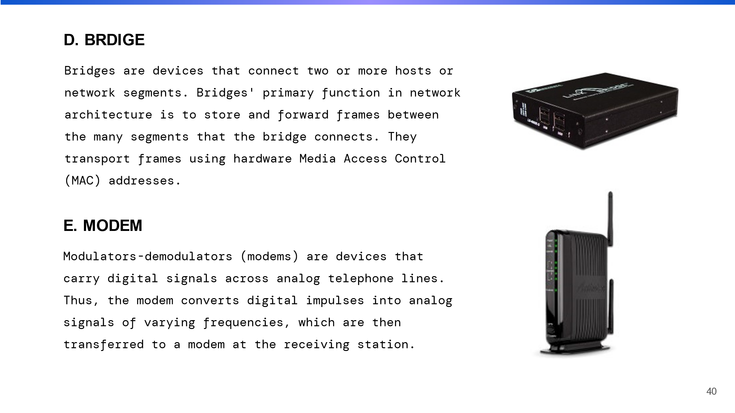

BRIDGE

It operates at the OSI model, data link layer (layer 2) and uses MAC addresses to determine the destination of each packet.

MODEM

It is a networking device that helps to convert signals from digital to analog.

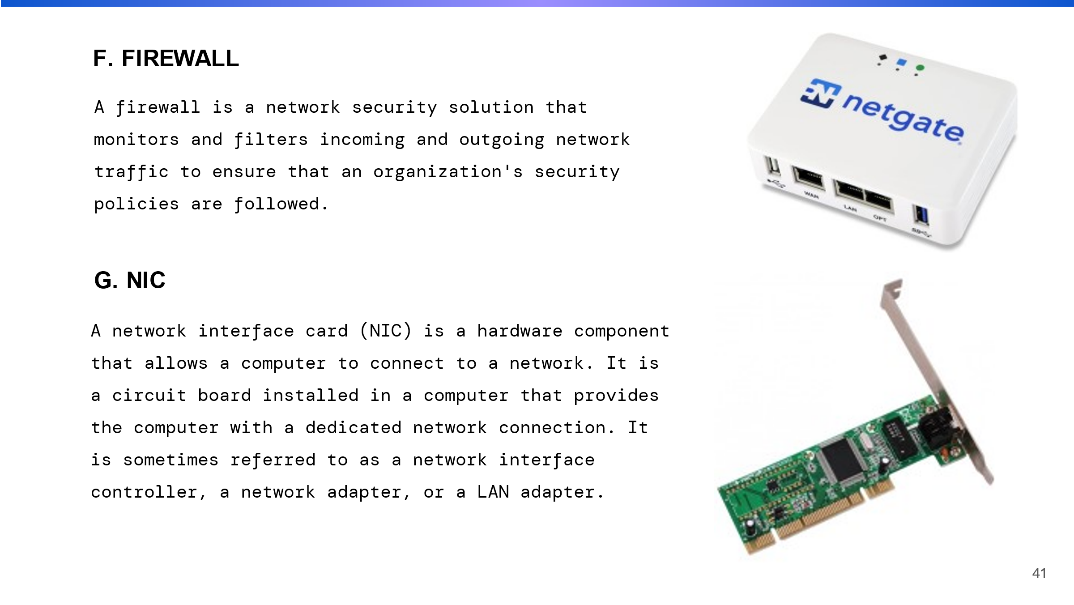

FIREWALL

A firewall is a device or piece of software that controls network access by enforcing a set of security rules. Its purpose is to keep the network safe from unauthorized access and malicious attacks.

**NIC**

It is a hardware component and consist of chip and connector that plugs into the device.

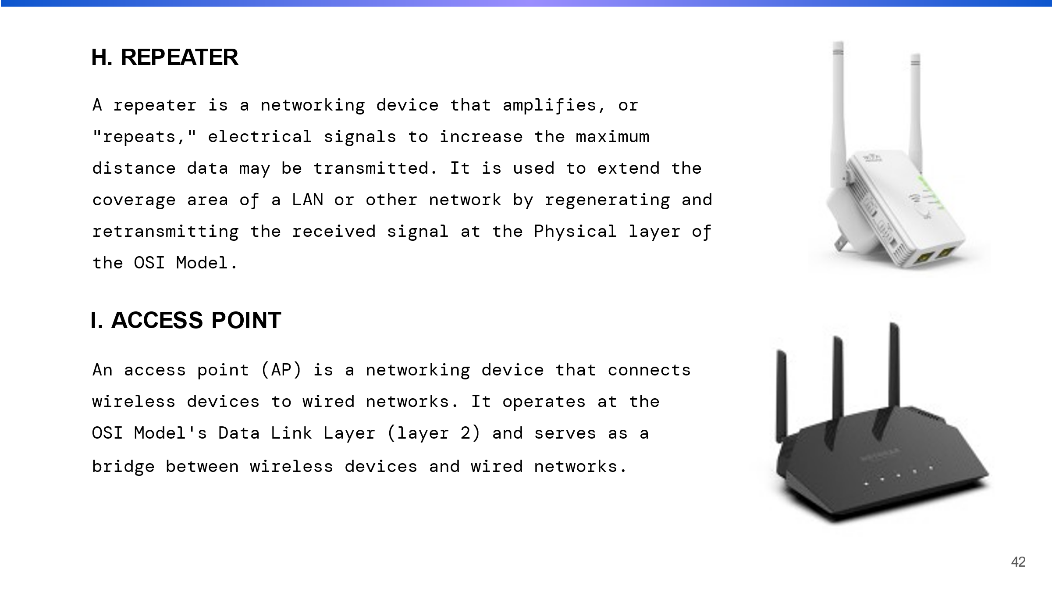

**REPEATER**

This device receives weak signal and retransmit it at strong signal. Repeater improve the signal strength and quality area where the signal is weak as remote and hilly area.

**ACCESS POINT**

This device connect to a router and allows wireless device such as laptops, smartphones, and tablets to connect to the internet.

IOT gateway

This device performs functions as data collection, protocol translation, and security and also helps to filter, aggregate .

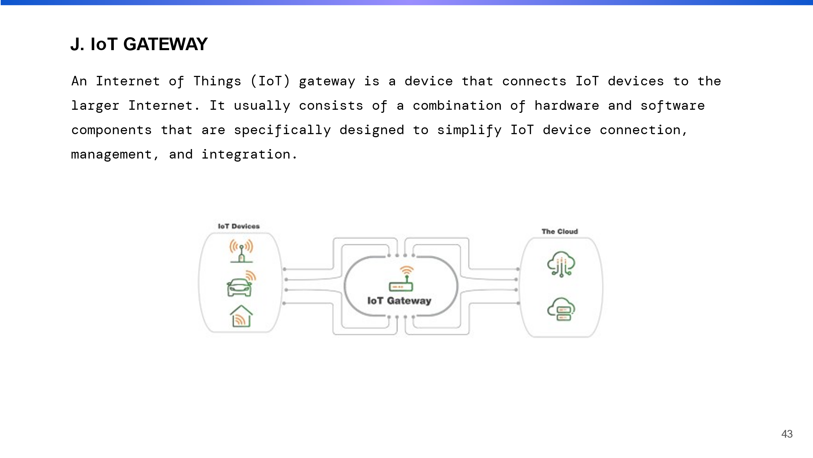

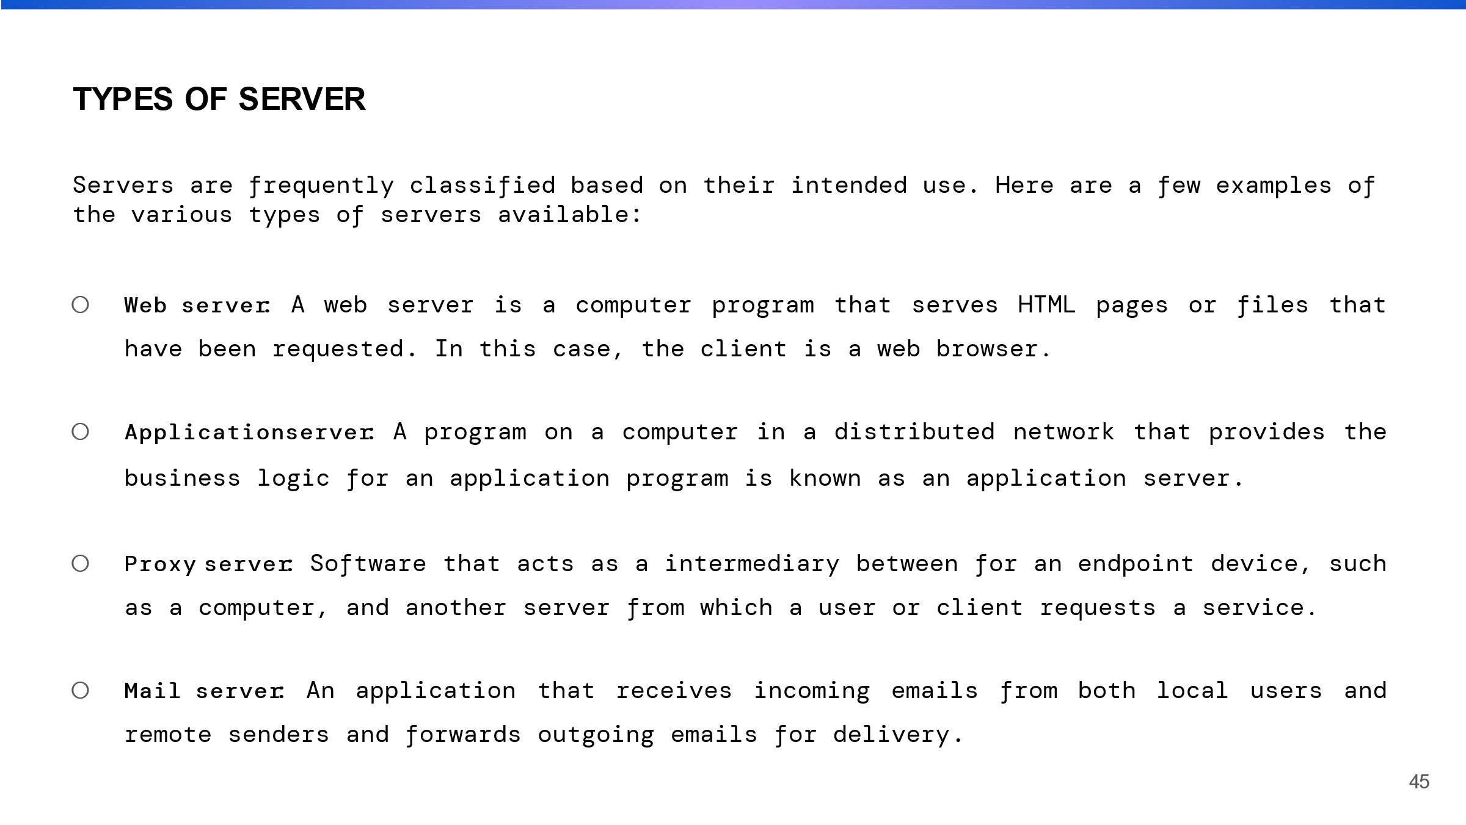

Server is system that provides resource, data and service. Some types of server are discussed that are:

Web server: These servers host websites and serve web pages to internet users.

Application server: this server run and manage application software.

Proxy server: this server receives request and forward to the appropriate server.

Mail server: this server manage and send emails.

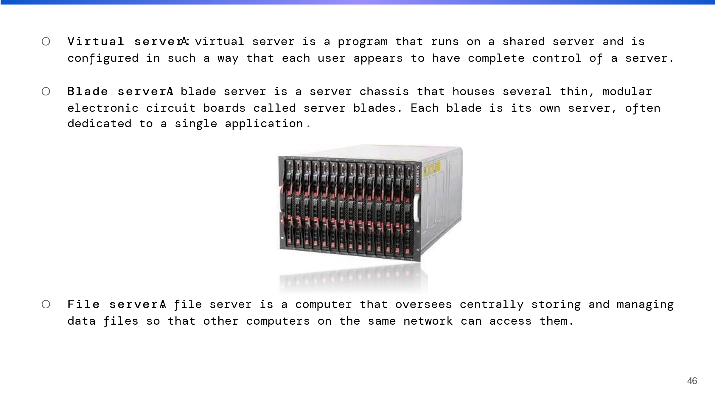

Virtual server: it is use to virtualization.

Blade server: this server is used in data centers, enterprise IT, and cloud computing to provide high performance computing.

File server: this server manage the files and share over a network.

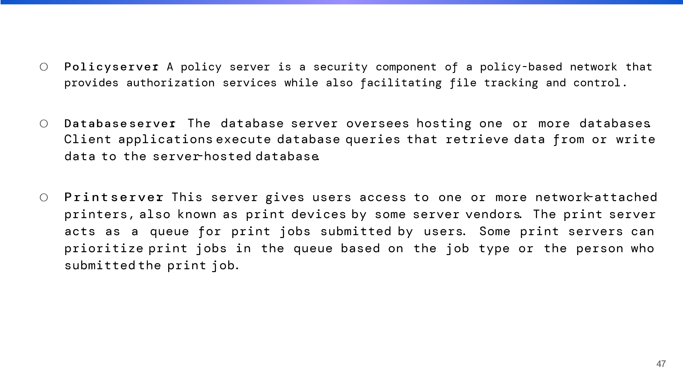

Policy server: this server is responsible for enforcing security and access policies.

Database server: this server is designed to store, manage, and provide access to database.

Print server: this server allow many computer to share the same printer.

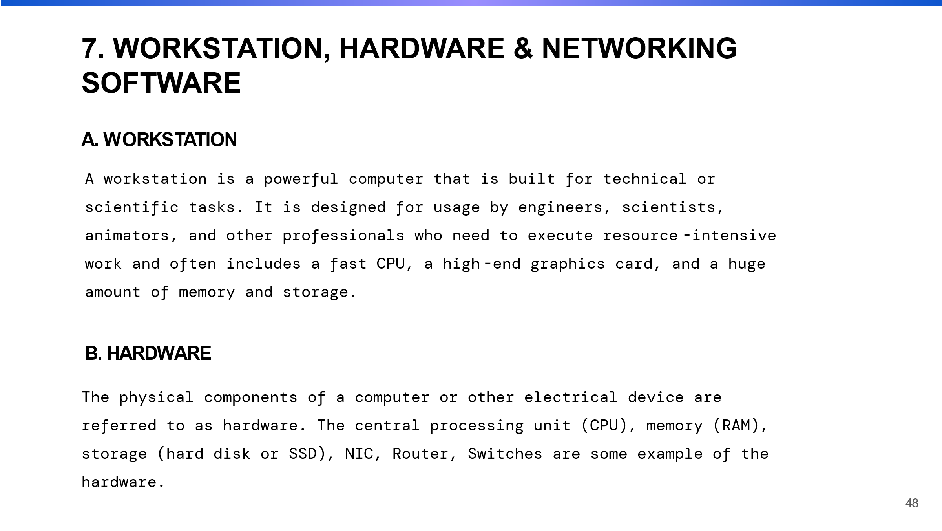

Workstation is most powerful computer that are used in wide range of industries like architecture, engineering, media and entertainment.

Hardware refers to the physical component of electronic device. We can upgrade and repair our hardware as per need for better performance.

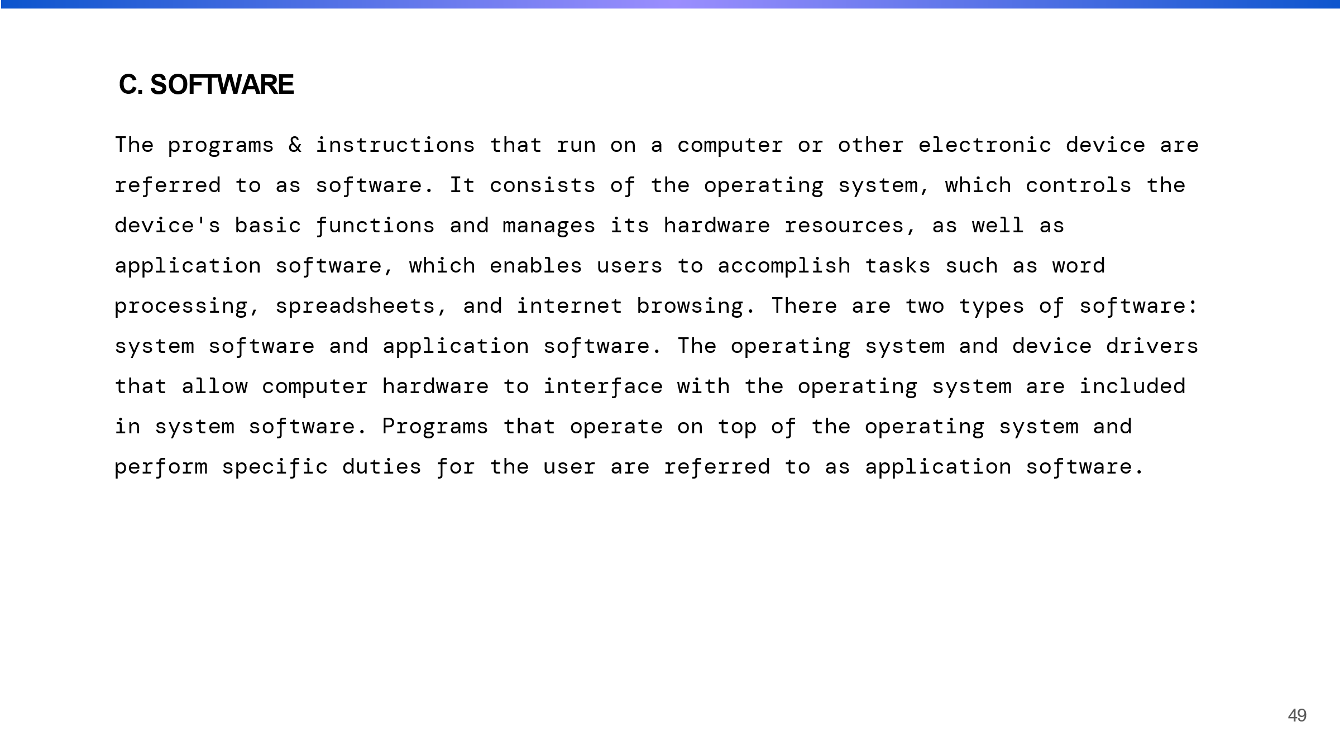

Software is non-physical component of computer, we can purchase ,download and update, upgrade, uninstall to improve the performance.



# Activity 2

# Introduction

As The planning and implementation of computer network infrastructure are referred to as network design. We require software to display the network connection between the devices and the server for the network design. I conducted research for the network's deployment in order to provide better services. A design that complies with a particular specification is created before a network is put into operation. The expected and actual output must match in order for the server services to pass testing and evaluation. After testing, the network system is put into practice based on a design that is recorded and the test results compared to what was anticipated. As such, the term "enhancement" refers to a change that enhances something's value or quality. For a more effective network, the suggested potential enhancement for the networked system should be implemented. We created a maintenance schedule to support the networked system while constructing it.

# Networking design

The process of planning and building a computer network infrastructure that meets the needs of an organization is known as network design. It entails determining the organization's requirements, evaluating the current network infrastructure, and designing a new network to address the identified needs.

There are several important factors to consider when designing a network:

Topology: The physical and logical layout of a network, including device placement, cabling use, and data routing.

Protocols: The protocols used for network communication, such as TCP/IP and OSI model.

Security: measures, such as firewalls, VPNs, and intrusion detection systems, protect the network from unauthorized access and attacks.

Scalability: The network's ability to grow and adapt to changing needs.

Reliability: The network's ability to maintain availability and performance under normal and abnormal conditions.

Manageability refers to the network's ability to be easily administered, monitored, and troubleshooted.

The design process is iterative, and multiple rounds of revisions and testing may be required before the final design is implemented. Network design is an important aspect of IT infrastructure because it has a significant impact on the organization's performance, security, and overall effectiveness.

## Network design of Cutting Edge IT Solution.

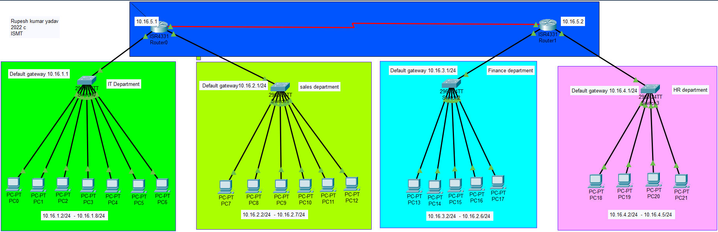

There are four department in cutting Edge IT company. IT department, sales department, finance department, HR department are the name of departments. In the IT department there are 7 computer and one switch, in sales department 6 pc and one switch, in Finance department 5 pc and one switch and in HR department 4 pc and one switch are connected. IT Department and Sales department are connected in router1. Finance Department and HR department network are connected with router2. Here I used total device are 2 router, 4 switch and pc as per need.

# Network device used in Cutting Edge IT company

I used router, switch and pc these devices are used individually or in combination to build a network that meets an organization's needs. The right networking devices will be chosen based on the organization's specific needs and the type of network being designed.

## Router

A router is a networking device that sends data packets from one computer network to another. It is linked to two or more networks and employs routing tables and protocols to determine the best path for data to take from one network to the next. Routers connect various networks, including a local area network (LAN), a wide area network (WAN), and the Internet. They use routing protocols like OSPF and BGP to share information about the networks to which they are connected and to determine the most efficient path for data to take.

Routers also serve other purposes, such as:

**IP address assignment:** Assigning IP addresses to network-connected devices via DHCP or static

IP addresses.

**Network Address Translation (NAT):** The process by which multiple devices on a private network share a single public IP address.

**Quality of Service (QoS):** Prioritizing certain types of traffic to ensure that important data takes precedence over less important data.

**Firewalls** protect networks from unauthorized access and attacks by controlling data flow.

**VPN:** A secure virtual private network (VPN) that connects remote devices to a network.

Routers can be standalone devices, integrated into a DSL or cable modem, or built into a network switch. The right router will be chosen based on the organization's specific needs and the type of network being designed.

## Switch:

A switch is a networking device that connects multiple devices within a local area network (LAN) and routes data based on the devices' Media Access Control (MAC) addresses. It operates at the OSI Model's data link layer (layer 2). A switch allows multiple devices to communicate within a network by forwarding data only to the device for which it is intended, as opposed to a hub, which broadcasts data to all connected devices. This improves the network's overall performance and security.

Other functions that switches can perform include:

VLANs (Virtual Local Area Networks): The creation of multiple virtual networks within a single physical network.

Quality of Service (QoS): Prioritizing certain types of traffic to ensure that important data takes precedence over less important data.

Link Aggregation: it is the process of combining multiple network connections to increase bandwidth and provide redundancy.

Port Mirroring: Sending a copy of all network traffic to a specific port for monitoring and analysis.

Access Control Lists (ACLs**):** Restricting access to specific parts of the network based on predefined rules.

Switches are classified as unmanaged, managed, or smart. Unmanaged switches are the most basic and least expensive, while managed switches provide more advanced features and configuration options, and smart switches include the ability to monitor and manage the network using software. The right switch will be chosen based on the organization's specific needs.

## IP address:

An IP address (Internet Protocol address) is a numerical label assigned to every device connected to a computer network that communicates using the Internet Protocol. It has two primary functions: identifying the host or network interface and locating the host in the network.

IP addresses come in two varieties: IPv4 and IPv6. IPv4 addresses are 32-bit numbers that are typically written in dot-decimal notation (e.g. 192.168.0.1). IPv6 addresses are hexadecimal numbers that are 128 bits long (e.g. 2001:0db8:85a3:0000:0000:8a2e:0370:7334).

IP addresses can be static or dynamic. A static IP address is one that is assigned to a device permanently, whereas a dynamic IP address is one that is assigned by a DHCP server and can change over time.

There are two kinds of IP addresses: public and private. Public IP addresses are unique globally and can be accessed via the Internet. Private IP addresses are reserved for use within a private network and are not accessible via the internet.

# Network address

A network address is a unique identifier assigned to a computer network device or group of devices. It is used to identify and locate network devices as well as to route data to the appropriate device. There are several kinds of network addresses, including IP addresses and MAC addresses. An IP address is a numerical label assigned to each device connected to a computer network that communicates using the Internet Protocol. A MAC address, or Media Access Control address, is a unique identifier assigned to network interfaces for physical network segment communications.

## IP Address used in Cutting Edge IT company.

|  |  |  |  |
| --- | --- | --- | --- |
| Cutting Edge IT Company | | | |
| **Department** | **IP address used in pc** | **Network Address** | **Subnet mask** |
| IT department | 10.16.1.2 - 10.16.1.8 | 10.16.1.1 | 255.255.255.0 |
| Finance department | 10.16.2.2 - 10.16.2.7 | 10.16.2.1 | 255.255.255.0 |
| HR department | 10.16.3.2 - 10.16.3.6 | 10.16.3.1 | 255.255.255.0 |
| Sales department | 10.16.4.2 - 10.16.4.5 | 10.16.4.1 | 255.255.255.0 |

|  |  |  |  |
| --- | --- | --- | --- |
| **Router name** | **Serial port** | **Ip address** | **Subnet mask** |
| RUPESH | Serial0/1/0 | 10.16.5.1 | 255.255.255.0 |
| Rupesh_2 | Serial01/0 | 10.16.5.2 | 255.255.255.0 |

# Hardware and software requirement

The physical components of a computer or device that are required for it to function properly are referred to as hardware requirements. These components include the processor, memory, storage, and others.

The programs and operating systems required for a device to function properly are referred to as software requirements. An operating system, a web browser, and specific applications or programs are examples of software requirements.

Specific hardware and software requirements will vary depending on the device or system and the tasks it is designed to perform.

Some required hardware and software to install and implement in workstation are shown below in table:

|  |  |
| --- | --- |
| Hardware and Software devices | Reason of using it (details) |
| Window server 2012 | This is Network Operating system which will execute on different workstation in Digital network solution. |
| ESET NOD32 Antivirus | Antivirus software that blocks viruses or unauthorized traffic over a network in Digital network solution. |
| CAT 7 Ethernet cable | It is high Shielded and requires GigaGate45 connection. It is too fast in short distance and max. speed is 100 GBPS which is totally applicable for Network digital solution Pokhara branch. |
| RJ 45 | It is twisted pair connector connects computer onto ethernet based LAN. |
| Router -Cisco | It provides high security services and connects more than two networks based for LAN, WAN and cloud to network digital solution Pokhara branch. |
| Switch-Cisco | It grows infrastructure and services by double figure with the same head count in Pokhara branch. |
| Firewall | Firewall has been providing security services on the basis of Hardware and Software Firewall. It blocks unauthorized and malware virus on Pokhara branch network and its sub branch offices. |
| Window 7 / Window XP | Window 07 and Window XP are applicable client operating system which is hard to bypass security of Pokhara branch. |
| Toolkit | Toolkits include various tools like router, connector, firewall devices and wires. |
| VPN | VPN stands for virtual Private Network which helps Pokhara branch to transfer data from one branch office to another through encrypted medium privately from VPN remote server. It created secure path for the data of Pokhara branch. |
| Printer | Dot Matrix printer are mostly used in office. It is fast and reliable printer. |

# Maintenance schedule

A maintenance schedule is a plan for inspecting, cleaning, servicing, and repairing equipment, machinery, or other assets on a regular basis. Maintenance tasks will vary in frequency and type depending on the item and its intended use. A maintenance schedule should be created in conjunction with the manufacturer's recommendations and any applicable safety and regulatory guidelines. The schedule should also be reviewed and updated on a regular basis to ensure its accuracy and effectiveness.

|  |  |  |
| --- | --- | --- |
| Maintenance day 1 | 4 hours(8am-12pm) | Thursday 10 jan 2023 |
| Upgrading hardware &software | (8 to 9 am) |  |
| Monitoring network performance | (9 to 10 am) |  |
| Checking network bandwidth | (10 to 11 am) |  |
| troubleshooting | (11 to 12am) |  |
| Maintenance day 2 | 3 hours (3 pm to 6 pm) | Friday 11 jan2023 |
| Managing database, creating backup | (3 to 4 pm) |  |
| Testing security susceptibility | (4 to 5 pm) |  |
| Updating security path | (5 to 6 pm) |  |
| Maintenance day 3 | 4 hours (3 pm to 7 pm) | Saturday 12 jan 2023 |
| Reviewing log file | 30 min (3 to 3:30 pm) |  |
| Reviewing active directory account | 30 min (3:30 to 4 pm) |  |
| Checking and testing the server | (4 to 5 pm) |  |
| Antivirus software installation | (5 to 6:30 pm) |  |
| troubleshooting | (6:30 to 7 pm) |  |

# Testing plan

A test plan is a document that outlines the strategy, approach, resources, and timetable for testing a piece of software or a system. It specifies the overall testing objectives, the scope of testing, the testing environment, and the testing approach. It also contains information on the types of tests that will be performed (such as unit testing, integration testing, and acceptance testing), the test schedule and milestones, and the testing team's roles and responsibilities.

The test plan should also include a section on expected results, which should include the expected result of each test, the criteria for determining success or failure, and any acceptance criteria that must be met before the software or system can be considered ready for release.

# Testing network design

|  |  |  |  |
| --- | --- | --- | --- |
| **S/N** | **Test subject** | **Predicted output** | **Actual output** |
| 1. | DHCP Server | DHCP assigns dynamic IP to client computer | When client connected to the network, it got IP address automatically or IP address were assigned to client computer dynamically. |
| 2. | Ping test | Ping command is a totally approach test for neigbourhood connectivity to a particular host, server, or tool. User ought to successful of ping to each Device of the LAN. | When User checked ping check in Command prompt, respond from receiver host appeared, as a give up result ping take a look at grew to be successful. |
| 3 | Secure shell host (SSH) | When User checked ping check in Command prompt, respond from receiver host appeared, as a give up result ping take a look at grew to be successful. | When User attempted to practice SSH with accurate password it grew to be successful. |

# Evaluation and feedbacks

|  |  |
| --- | --- |
| **Project title: Cutting edge IT company** | |
| **Feedback given by: Anit tamang** | **Signature:**  **Date: 2020/05/07** |
| **Description of Project:** The main objective of the project is made an effective plan with the management of the design and implementation of the networked system for cutting edge IT Company. | |
| **Features of the project:** Through the effective plan, there is a secured connection between the head and the branch office. Inside the head office, the pcs are connected with each other so that the data is exchanged between the pcs form the branch office too. By the use of the latest networking devices and the servers in the LANMARK IT Pvt. Ltd, there is Powerful security. | |

|  |  |  |  |  |  |
| --- | --- | --- | --- | --- | --- |
| S.N. | Check list | Yes | No | | Comment |
| 1. | Is the requirement of clients have been fulfilled? |  |  | | The user requirement is fulfilled according to their needs. |
| 2. | Is a design of the network has worked efficiently? |  |  | | Yes, it has worked effectively by fulfilling the client’s requirements. |
| 3. | Does the system have backup the data for future needs? |  |  | | Yes, there is a backup of the data in the cloud as well as by making the cluster of the data. |
| 4. | Does the system requirements have been defined and are they clear? |  |  | | Yes, they are defined and almost all are fulfilled. |
| 5. | Does the system solve the problem of the client? |  |  | | Yes, practically all of them are fulfilled. |
| 6. | Does the system have been implemented in align with the proper design? |  |  | | Yes, the system has been implemented effectively. |
| **Significance of the project:** The network system of Cutting Edge IT solution is more secured. There is main domain controller which can control, monitor and manipulate the entire client pcs inside and outside the head office. Through, the use of the distinctive servers like RODC, CDC, VPN, print server, the communication has been easy between the head and branch office. | | | | | |
| **Project Limitation:** Though the system has been successfully implemented and made a numerous change in the Cutting Edge IT solution, there are some of the limitation within the system. for the reason that the system carries out via the domain -based community. There can be a traffic between the network through the numerous requests at a time. The system may be in the problem because of the conserving of the entire pc and networking device within the equal network. | | | | | |
| **Feedback Evaluation** | | | | | |
| **Feedback evaluated by: Anit Tamang** | | | | **Signature:**  **Date:2020/05/07** | |
| **Evaluation of the system:** | | | | According to the feedback, there are almost good aspects as well as some lack which are to be fulfilled at the time of maintenance or at the time of the upgrade with the client wise. But, for now the network system of LANMARK IT Pvt. Ltd is secured and strong and working as per the client needs. | |

When the Domain controller is set up, there we have seen the centralized network of a company, there is a website of the company where DNS (Domain Name services) helps to provide IP for the website and the information is updated through the IIS (Internet Information Services). In a company the DHCP (Dynamic Host Configuration Protocols) had provide the IP to the client computer individually and requests and replies between clients and servers are forwarded through the DHCP relay agent where there is no any same physical subnet. The used of print server had made efficient work done by all the client pcs. The used of VPN has made the connection secured and helps us to unblock the block website at a needy time. For the backup of the data the used of CDC had help us which is also known as subdomain. As a RODC server has improve the security in the branch office. We have installed the OS to all the Client pcs by the use of Window deployment services (WDS) which had increased the working efficient inside a company.

# Range of server types

There are many ranges of server types. In my point of view some of the must leading server types are IBM server, Dell server and Hp server which I am going to compare them individually. In the IBM server, Dell server and Hp server, I will take the IBM system x3650, Dell PowerEdge 2970 and HP ProLiant DL380 G5.

|  |  |  |  |  |
| --- | --- | --- | --- | --- |
| **S.N.** | **Systems** | **Dell PowerEdge 2970** | **HP ProLiant DL380 G5** | **IBM system x3650** |
| **1**. | **CPU** |  |  |  |
| a. | Vendor | AMD | Intel | Intel |
| b. | Name | Opteron 222 SE | Xenon 5160 | Xenon 5160 |
| c. | Core frequency (GHz) | 3.0 GHz | 3.0 GHz | 3.0 GHz |
| **2**. | **Processor** |  |  |  |
| a. | No. of processor packages | 2 | 2 | 2 |
| b. | Number of cores per processor package | 2 | 2 | 2 |
| **3**. | **Graphics** |  |  |  |
| a. | Vendor and model number | ATI ES 1000 | ATI ES 1000 | ATI ES 1000 |
| b. | Chipset | ATI ES 1000 PCI | ATI ES 1000 PCI | ATI ES 1000 PCI |
| c. | Type | Integrated | Integrated | Integrated |
| d. | Memory size | 16GB | 32GB | 16GB |
| **4**. | **Network card** |  |  |  |
| a. | Vendor and model number | Broadcom NetXtreme II Gigabit | NC373i Multifunction Gigabit Network Adapter | Broadcom NetXtreme II Gigabit & intel PRO/1000 PT |
| b. | Type | Integrated | Integrated | PCI |
| **5**. | **Optical drive** |  |  |  |
| a. | Vendor and model number | TEAC CD-224E | TEAC DV-W28EA | TEAC UDJDA-770 |
| b. | Type | CD-ROM | DVD/CDRW | DVD/CDRW |
| c. | Interface | IDE | IDE | IDE |
| d. | Dual/single layer | Single | Dual | Dual |
| **6**. | **USB ports** |  |  |  |
| a. | Number of ports | 4 | 5 | 6 |
| b. | Type of ports (USB 1.1, USB 2.0) | USB 2.0 | USB 2.0 | USB 2.0 |
| **6**. | **Hard disk** |  |  |  |
| a. | Vendor and model number | Seagate ST973451SS | Seagate ST973451SS | Seagate ST973451SS |
| b. | Number of disks in system | 5 | 5 | 5 |
| c. | Size | 73 GB | 73 GB | 73 GB |
| d. | Buffer size | 16 MB | 16 MB | 16 MB |

Though all these server type has its own features which have their own importance and it is difficult to choose among these three server types. Among these range of server types, I would have selected Dell server for my company. In the topic of price and performance, I would like to use the dell server series because the price is cheap and best for the workable environment. Our company works for the web hosting, network service provider, data management & recovery and maintenance of network as well as networking devices. To do all these services we need a good laptop having at least 16 GB ram with 2 processor. There is no need of more than 16 GB of ram. Though there is a more ram in HP server, it will be waste of remaining memory. The dell server is good for the small company. There is a good feature of ram, processor, graphics and hard disk. The company need to work on many networking services as well as device. Nowadays, the dell server pcs are leading the market and has been using the latest technology for the improvement also. The price of this server is affordable by the company also. Though the HP and IBM series have different market value on the basis of the component contains in it. The dell server has its own value among these two servers. In my view, the dell server has all the needy things which all the company needed. The dell server has the hard disk similar to these two servers. To make the work efficient level high, I have selected the dell server which is my best choice in my view.

# Purpose of network design:

The goal of network design is to create a plan for the implementation and configuration of a computer network that meets an organization's specific needs and requirements. Network design entails the selection of network hardware, software, and topology, as well as the creation of policies and procedures for network management, maintenance, and security.A well-designed network will support the organization's business goals and objectives by providing reliable and efficient communication between devices and users. Scalability, security, and flexibility will also be provided to accommodate future growth and changes.

The following are the primary goals of network design:

* To ensure consistent and efficient communication between devices and users.
* To assist in the achievement of the organization's business goals and objectives.
* Scalability, security, and flexibility are required to accommodate future growth and changes.
* To reduce costs while maximizing resource utilization.
* To ensure that industry standards and regulations are followed.
* To provide a foundation for the development of new applications and services.
* To assist with disaster recovery and business continuity planning for the organization.

Overall, network design is an important step in the successful deployment and management of a computer network infrastructure.

# Recommendation:

To improve the entire network of the Cutting Edge IT solution, there must be the use of the latest technologies like, instead of switch there must be the use of router, the company must make the system security strong so that, the data is safe, there must the used of fortigate firewall, there must be use of VPN inside the branch company so that the connection over the internet is secured, the use of biometrics on the network. The network must be centralized so that the security become strong and can be handled easily.

# Conclusion:

In this part I have mainly focused on the basic knowledge of networks. In a simple meaning, Network is a group of two or more than two computer system which is linked with each other. I have described the different network types etc. and the network standard are describe.

# Activity 3

# Introduction

An ideal network design would be described in a technical report together with implementation data, testing and analytical findings, and recommendations for further improvements. For this section of the report, I will provide a technical report that includes all necessary paperwork for the best design's effective implementation, an analysis of the test plan's outcomes, and recommendations for future networked system enhancements.

# Technical report

A technical report is a document that describes the methods, procedures, findings, and conclusions of a technical or scientific research or project. Technical reports are used to inform a specific audience, such as engineers, scientists, managers, or other technical experts, about the details of a project or study. A technical report will usually contain the following sections:

Introduction: This section provides context for the project or study, such as its purpose, objectives, and scope.

Methodology: This section describes the research or project's methods and procedures, including the materials, equipment, and techniques used.

Results: This section presents the research or project's data and findings, including tables, graphs, and figures to illustrate the findings.

Discussion: In this section, the results are interpreted and analyzed, and their implications and significance in relation to the project or study objectives are discussed.

Conclusion: This section summarizes the research or project's main findings and conclusions and makes recommendations for future work.

References: This section includes a list of the sources used in the report, such as books, articles, and other publications.

Appendices: Any additional material that supports the report, such as raw data, calculations, and photographs, is included in this section.

To meet the given requirement, I designed our network using a star topology with two Cisco routes and four Cisco switches.

## System requirement

Based on the scenario following were the system requirements:

* IT department: 7 PC
* Finance department: 5 PC
* HR department: 4 PC
* Sales department: 6 PC

## Tools used

To simulate the network, we will use Cisco Packet Tracer version 8.2 64-bit, which can be downloaded here.

Cisco Packet Tracer 64-bit is a powerful network simulation tool that allows students to experiment with network behavior and ask "what if" questions. Packet Tracer is part of the Networking Academy's overall learning experience and offers simulation, visualization, authoring, evaluation, and collaboration capabilities, in addition to supporting the teaching and learning of difficult technical topics.

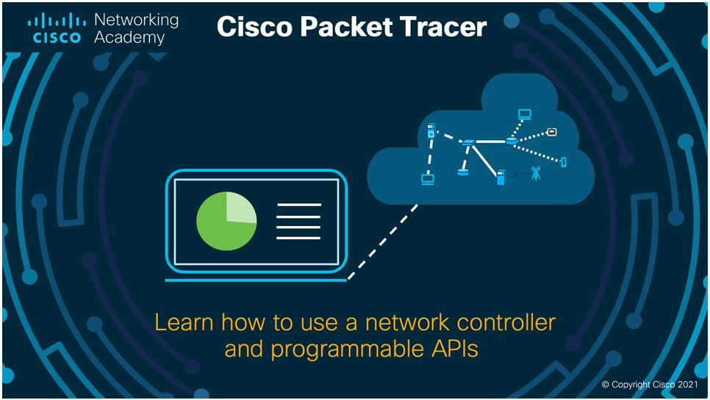

Application:

FTP, SMTP, POP3, HTTP, TFTP, Telnet, SSH, DNS, DHCP, NTP, SNMP, AAA, ISR VOIP, SCCP config and calls ISR to command support, Call Manager Express.

Transport:

TCP and UDP, TCP Nagle Algorithm & IP Fragmentation, RTP

Network:

BGP, IPv4, ICMP, ARP, IPv6, ICMPv6, IPSec, RIPv1/ v2/ng, Multi-Area OSPF, EIGRP, Static Routing, Route Redistribution, Multilayer Switching, L3 QoS, NAT, CBAL, Zone-based policy firewall and Intrusion Protection System on the ISR, GRE VPN, IPSec VPN.

Network Access Interface:

Ethernet (802.3), 802.11, HDLC, Frame Relay, PPP, PPPoE, STP, RSTP, VTP, DTP, CDP, 802.1q, PAgP, L2 QoS, SLARP, Simple WEP, WPA, EAP.

# Configuration

I install cisco packet tracer and setup then took 2 router and 4 switch .

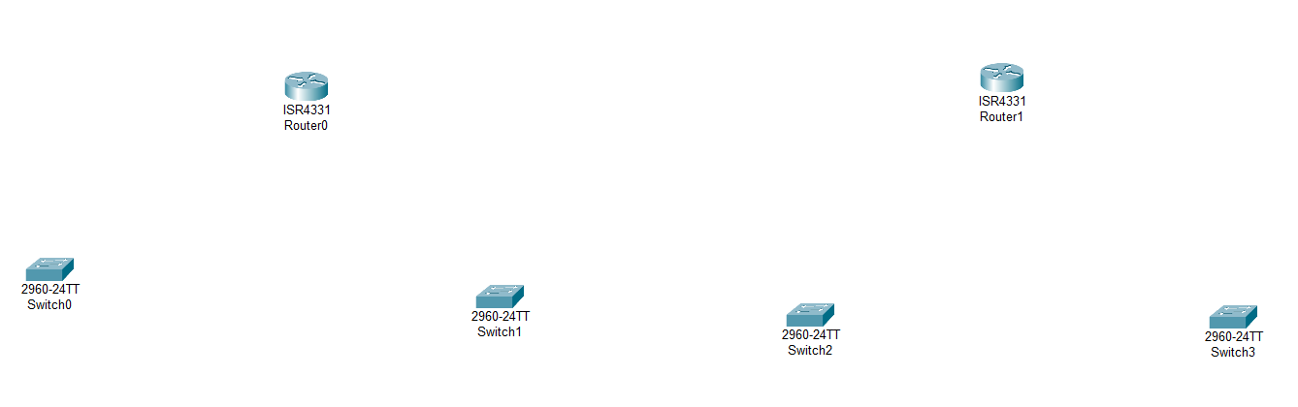

* Then connect them through automatic wire .

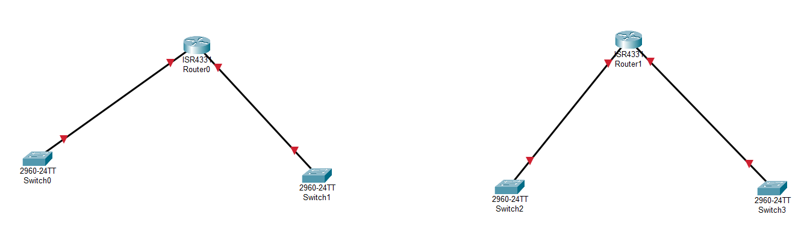

* Then I switch off the router to add NIM-2T component in both the routers.

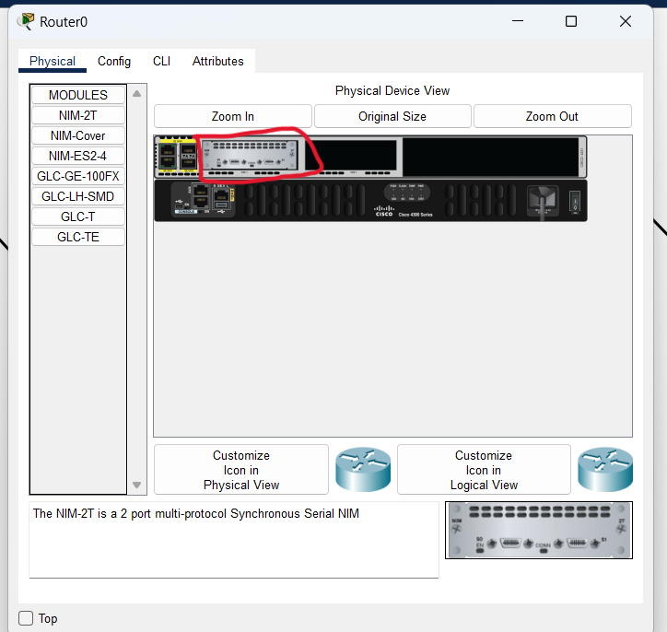

* Then we connect serial cable

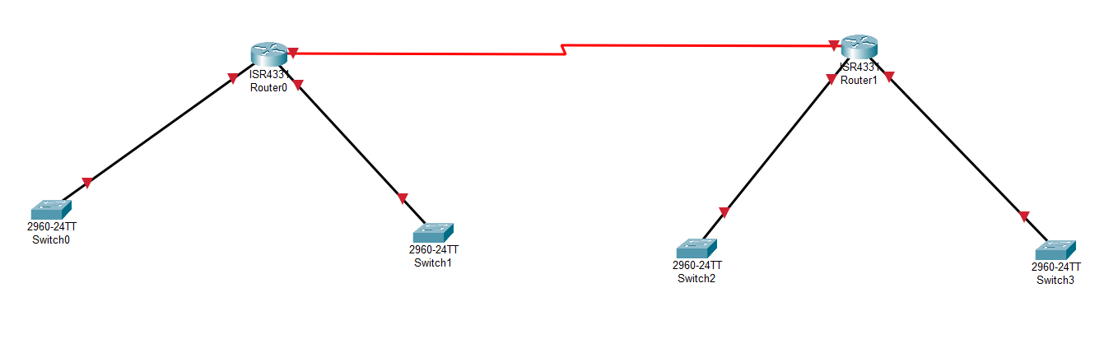

* Then routers and switches are connected and started adding PC in all the department.

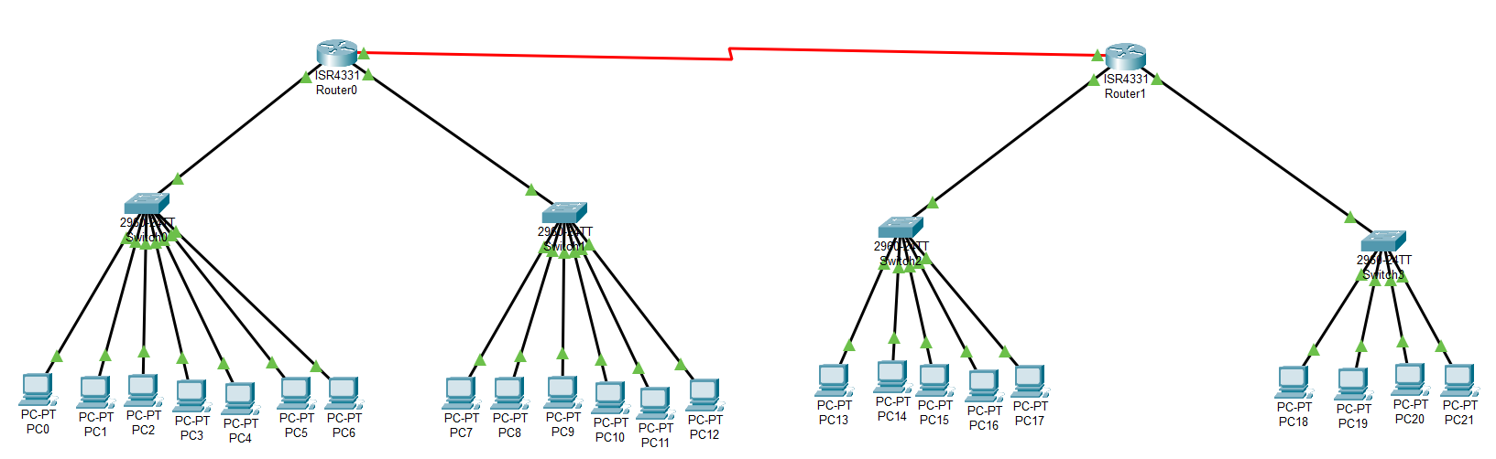

* IP address / subnetting are configured in every pc. Table of IP address that I given in pc are given below:

|  |  |  |  |
| --- | --- | --- | --- |
| **Department** | **IP Address Range** | **Subnet** | **Subnet Mask** |
| IT Department | 10.16.1.2 - 10.16.1.8 | /24 | 255.255.255.0 |
| Finance Department | 10.16.2.2 - 10.16.1.7 | /24 | 255.255.255.0 |
| HR Department | 10.16.3.2 - 10.16.1.6 | /24 | 255.255.255.0 |
| Sales Department | 10.16.4.2 - 10.16.1.5 | /24 | 255.255.255.0 |
| Routers | 10.16.5.1 - 10.16.5.2 | /24 | 255.255.255.0 |

Finally, network are designed and its look like the given Screenshot:

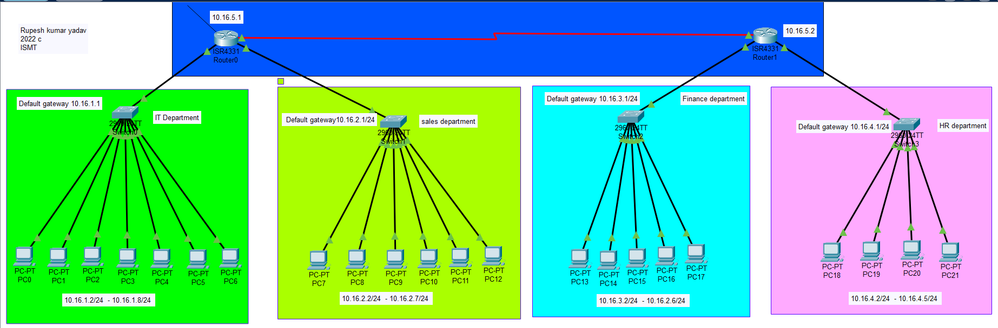

Ip configuration in pc for every department that evidence are given below through screenshot.

* IP address and network address/Gateway is added in **IT department** of every pc. There are 7 pc in IT department. Here, I put evidence and this way in every pc are configured IP and gateway.

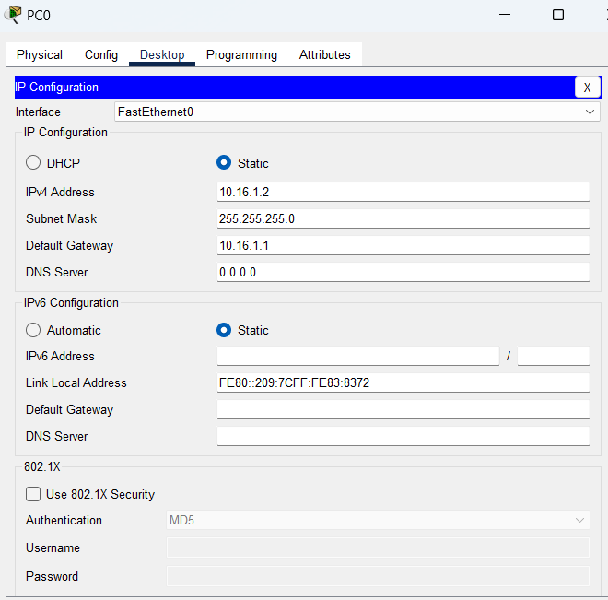

* Sales department

IP address and network address/Gateway is added in every pc. There are 6 pc in Sales department. This way in every pc are configured IP and gateway screenshot is given for evidence.

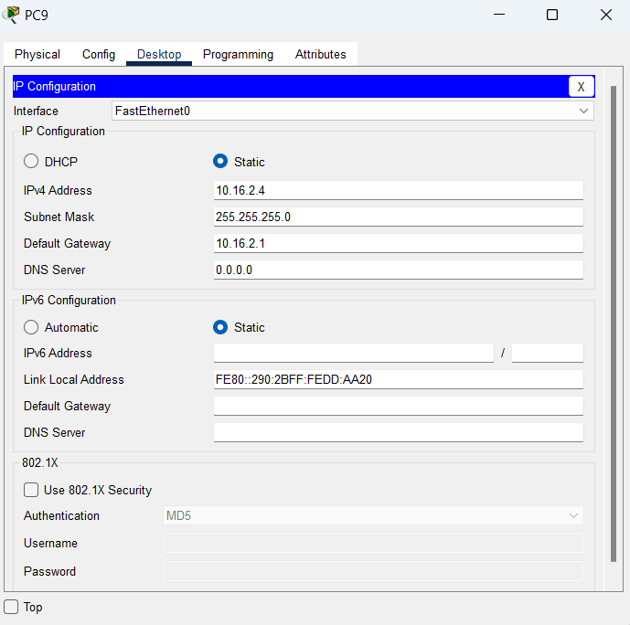

* **Finance department**

IP address and network address/Gateway is added in every pc. There are 5 pc in Sales department and pc16 is in finance department. This way in every pc are configured IP and gateway screenshot is given for evidence.

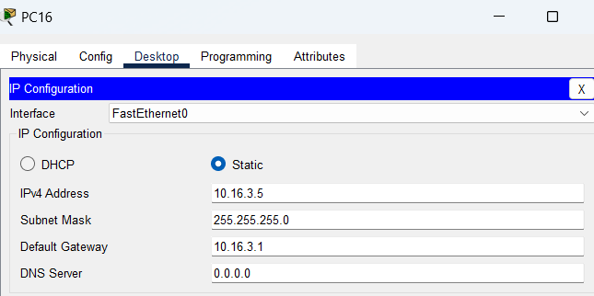

* **HR department**

IP address and network address/Gateway is added in every pc. There are 4 pc in HR department and pc21 is in HR department. This way in every pc are configured IP and gateway screenshot is given for evidence.

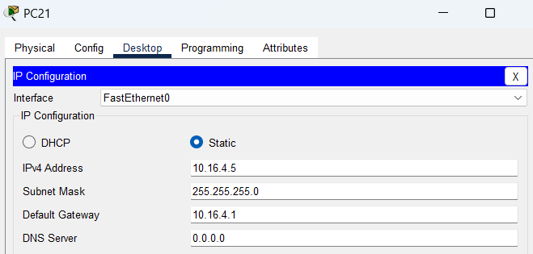

* Ip configuration of router

I changed the router name from router0 to RUPESH

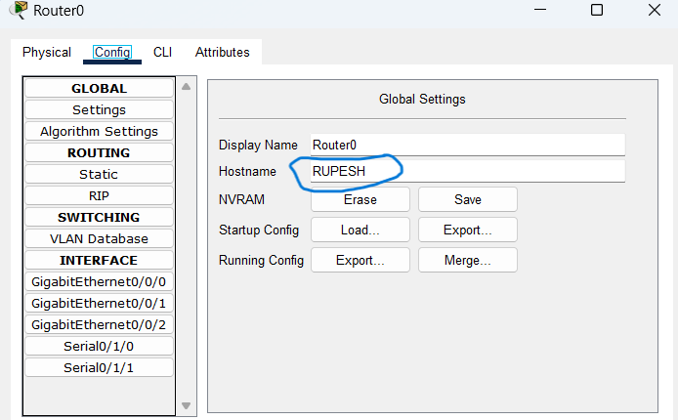

* IP configure in router0/RUPESH of GigabiEthernet0/0/0

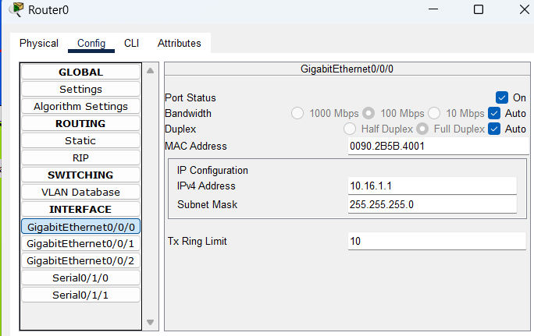

* IP configure in router0/RUPESH of GigabiEthernet0/0/1

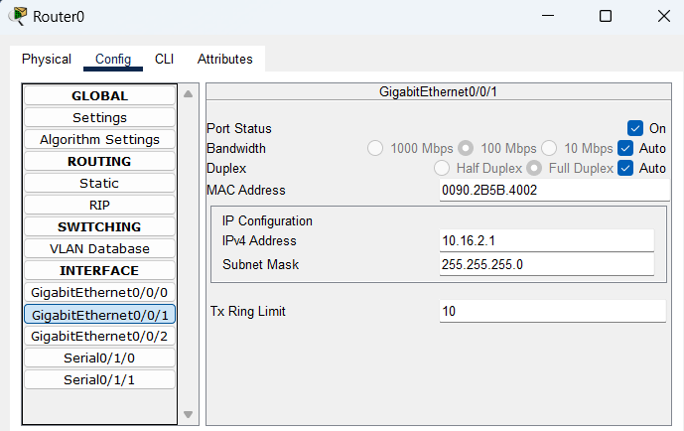

* IP configure in router0/RUPESH of Serial0/1/0

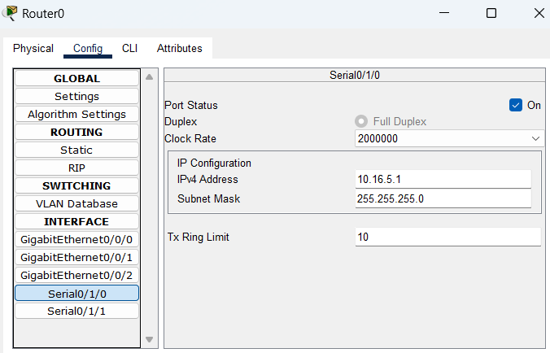

* Router0/RUPESH static routing config

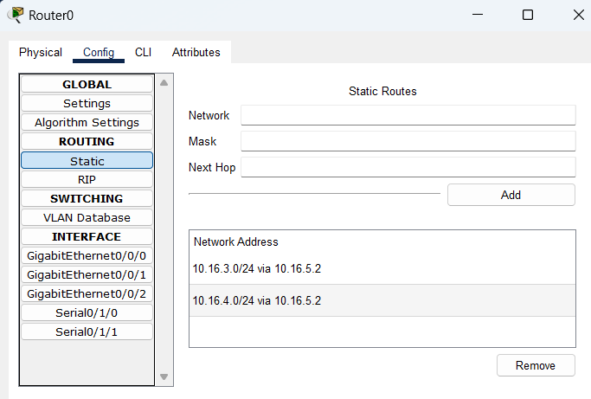

* IP configuration of Router1/Rupesh_2
* I changed the router name from router1 to Rupesh_2

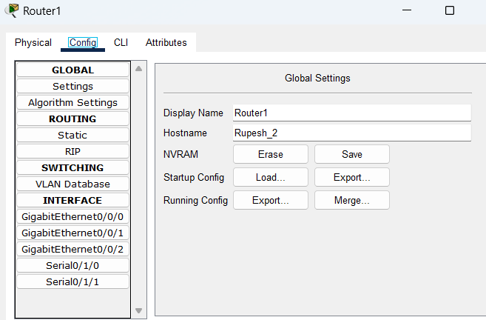

* IP configure in router1/Rupesh_2 of GigabiEthernet0/0/0

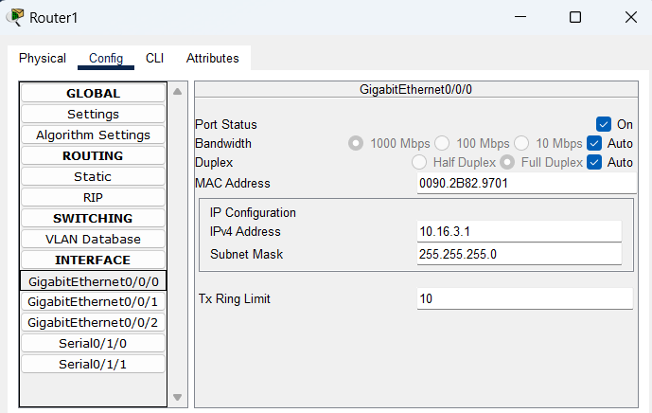

* IP configure in router1/Rupesh_2 of GigabiEthernet0/0/1

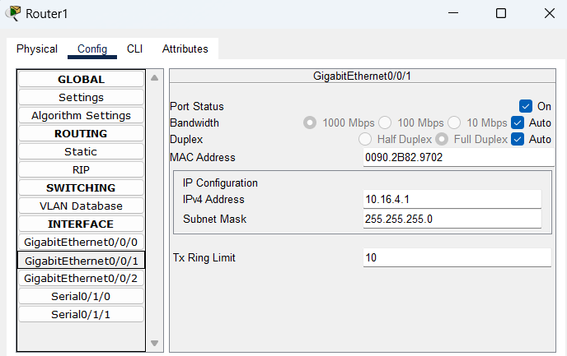

* IP configure in router1/Rupesh_2 of GigabiEthernet0/0/0

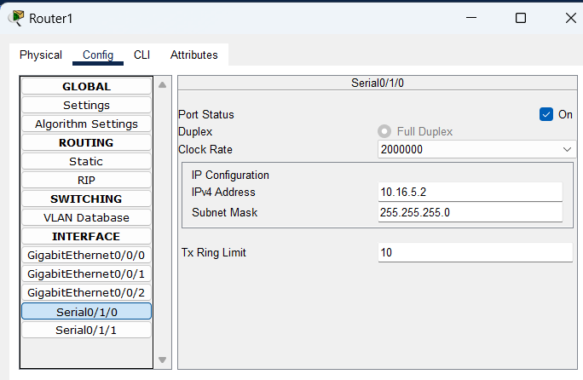

* IP configure in router1/Rupesh_2 of serial0/1/0

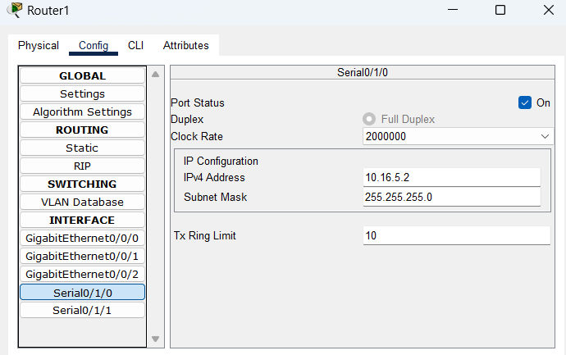

* Router1/Rupesh_2 static routing config

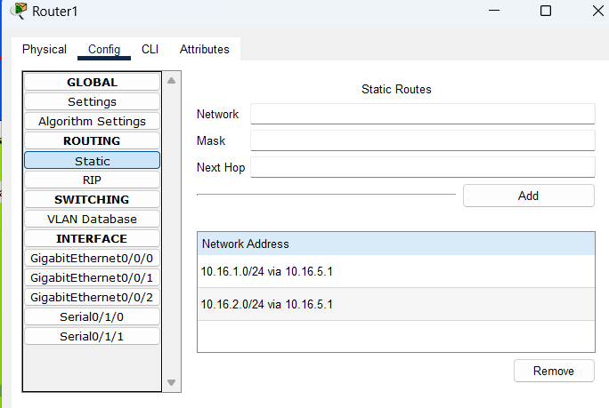

### Testing Results

Once we implemented IP address & routing on both the routers it’s time to test the network system. Below is the expected vs real output that we got.

|  |  |  |  |
| --- | --- | --- | --- |
| Test Log: 01 | | | |
| Test: Check communication between IT department computers. | | | Date: 2023/11/05 |
| SN. | Expected result | Actual result | Remarks |
| 1 | When we ping from PC0 to PC7, we expect to receive a ping response with no data loss. | As expected, we received ping from the PC0 in IT department with no data loss. | Success |
|
| Figure: Image of IT department network.    Figure: Ping test from PC 0 to PC 7 | | | |

|  |  |  |  |
| --- | --- | --- | --- |
| Test Log: 02 | | | |
| Test: Check communication between IT & HR department computers. | | | Date: 2023/01/03 |
| SN. | Expected result | Actual result | Remarks |
| 1 | We expect to get ping reply from the Finance department PC when we ping it from PC7 in IT department with no data loss. | As expected, we received ping from the PC21 in HR department with no data loss. | Success |
|
| Figure: Network of IT &Finance department    Figure: Ping test from PC 5 to PC 7 | | | |

|  |  |  |  |
| --- | --- | --- | --- |
| Test Log: 03 | | | |
| Test: Check communication between Finance & sales department computer. | | | Date: 2023/01/03 |
| SN. | Expected result | Actual result | Remarks |
| 1 | We expect to get ping reply from the Finance department PC when we ping it from PC7 to PC17 in finance department with no data loss. | As expected, we received ping from the PC7 in HR department with no data loss. | Success |
|
| Figure: Image showing network of finance & sales Department    Figure 1: Ping test from PC 0 to PC 12 | | | |

Let's put the network to the test with the tracert command. The tracert (or traceroute) command is a utility for tracing an information packet's path from its origin to its destination. It shows the sequence of intermediary devices (routers or other network equipment) that the packet passes through, as well as the time it takes for the packet to reach each device. This is critical for troubleshooting network connectivity issues because it allows you to determine where a problem may be occurring along the way.

|  |  |  |  |
| --- | --- | --- | --- |
| Test Log: 04 | | | |
| Test: Check the route to the PC in IT department from HR Department. | | | Date: 2023/01/03 |
| SN. | Expected result | Actual result | Remarks |
| 1 | We expect to get the route. | As expected, we received the output of tracert command. | Success |
|
| Figure: tracert test from PC 0 to PC 19 | | | |

|  |  |  |  |
| --- | --- | --- | --- |
| Test Log: 04 | | | |
| Test: Check the route to the PC in sales department from finance Department. | | | Date: 2023/01/03 |
| SN. | Expected result | Actual result | Remarks |
| 1 | We expect to get the route. | As expected, we received the output of tracert command. | Success |
|
| Figure 2: tracert test result which was made from PC 08 to PC 16 | | | |

|  |  |  |  |
| --- | --- | --- | --- |
| Test Log: 05 | | | |
| Test: Check communication between Router 0 and Router 01 | | | Date: 2023/01/03 |
| SN. | Expected result | Actual result | Remarks |
| 1 | We expect to get ping response from Router 0 when sending request from Router 1 with no loss. | We received ping response from Router 0 with no data loss. | Success |
|
| Figure 3: Ping test from Router 01 to Router 0 | | | |

### Potential Enhancement

* Although the network system we designed for our branch is fully functional, there are several things that can be done to improve it in the future. I'll go over some of the potential network improvements that can be made in the future.
* I Use a network monitoring tool.
* We do not currently have any network monitoring tools in our branch office. To monitor and control network activity, a network monitoring tool can be used. I'll list some useful open-source network monitoring tools below:
* Grafana is a free and open-source tool for metric visualization and analysis. It enables users to query, view, and receive alerts on metric data stored anywhere. Grafana is a powerful and adaptable tool for creating, exploring, and sharing data dashboards.

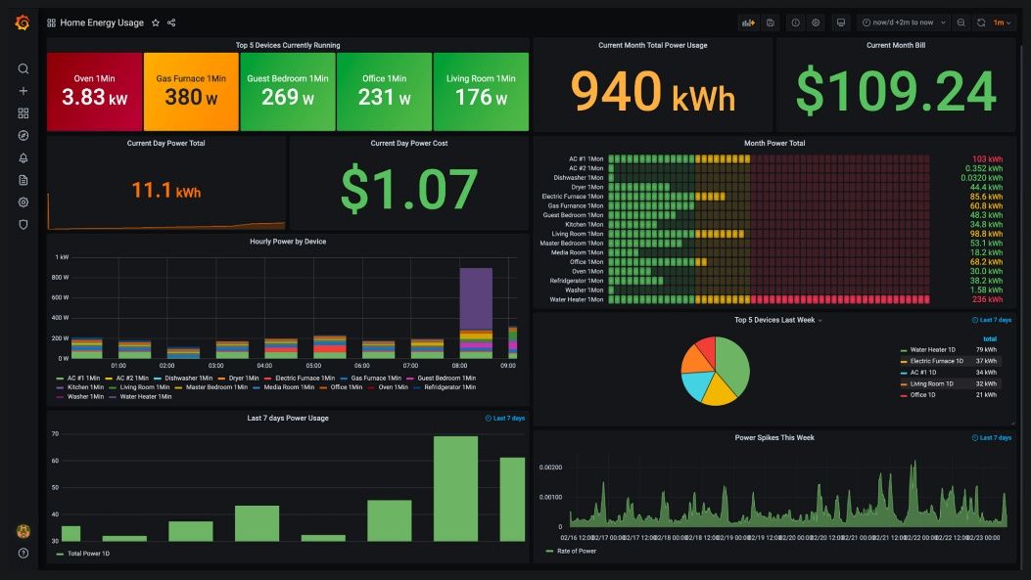

Figure: Image of Grafana dashboard

- Nagios is a network monitoring program for servers, network devices, and other network resources that is free and open source. It can be used to check the availability of resources such as servers, switches, routers, and applications, as well as to detect and alert on issues such as high CPU or memory utilization, high network traffic, or failed services.

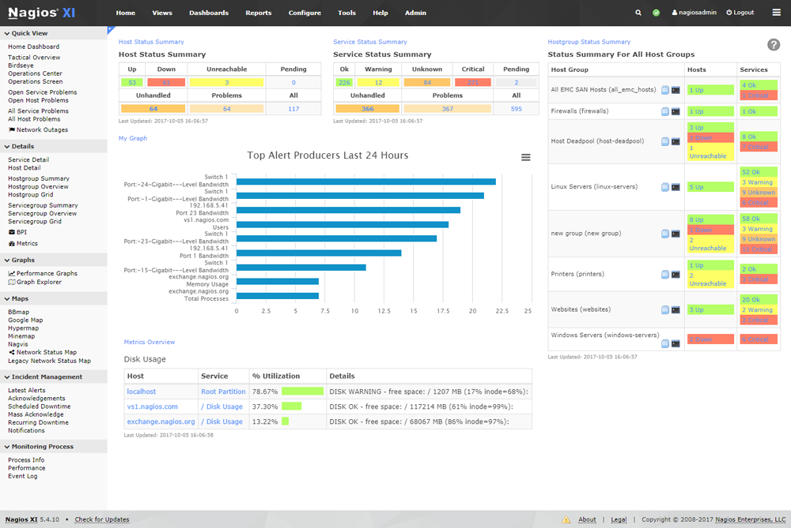

Figure: Image of Nagios dashboard

- Zabbix is a network monitoring application for servers, network devices, and other network resources that is free and open source. It is designed to be highly scalable and capable of monitoring large, complex networks. It can be used to check the availability of resources such as servers, switches, routers, and applications, as well as to detect and alert on issues such as high CPU or memory utilization, high network traffic, or failed services.

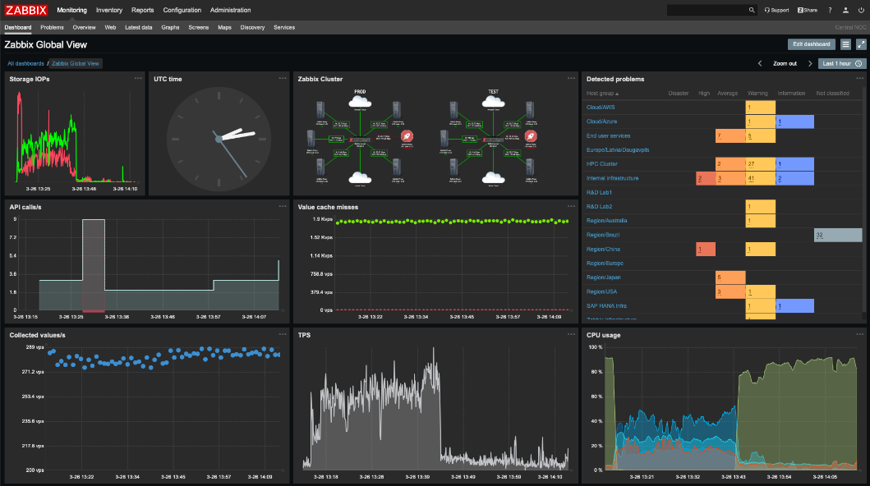

Figure 4: Image of Zabbix Dashboard

#### Implement Firewall and Alert system

A firewall is a type of network security device that analyzes incoming and outgoing network traffic and determines whether certain traffic should be allowed or denied based on a set of security rules. Firewalls have traditionally been the first line of defense in network security. They serve as a barrier between trusted internal networks and untrustworthy external networks such as the Internet. A firewall can be hardware, software, software-as-a-service (SaaS), or cloud-based (public or private) (virtual). n.d. (cisco.com)

As a result, we can easily implement a firewall to control the incoming and outgoing traffic in our network system.

#### Implement Redundancy Router

A backup or failover router is a network device that serves as a backup or failover mechanism if the primary router fails or becomes unavailable. A redundancy router's primary function is to ensure that network traffic is routed even if the primary router fails. There are several methods for deploying a redundancy router in a network, but the following are the most common:

- Protocol for hot standby routers (HSRP)

- VRR Protocol (Virtual Router Redundancy Protocol) (VRRP)

- Load Balancing Protocol for Gateways (GLBP)

- HSRP: HSRP is a Cisco proprietary technology that allows multiple routers to work together to appear as a single virtual router on a LAN. A virtual IP address is assigned to the virtual router, and one of the routers is designated as the active router, with the others in standby mode.

- VRRP: VRRP is an open standard protocol that is similar to HSRP. It allows multiple routers to work together to give hosts on a LAN the appearance of a single virtual router. The virtual router has an IP address, and one of the routers is designated as the master router, with the others serving as backup.

In general, using a redundancy router in the network architecture may improve network availability and dependability while also minimizing downtime and enhancing overall network performance.

# Conclusion

# Activity 4

# Introduction

# Selection of topology

The selection of a network topology is determined by the network's specific requirements and constraints. Consider the following factors when selecting a topology:

The number of devices that must be connected will influence the topology chosen. A small network with a few devices, for example, may be best served by a star topology, whereas a larger network may require a more complex topology, such as a mesh or hybrid.

* Distance between devices: The physical distance between devices influences the topology chosen. A bus topology, for example, may be appropriate for devices that are close together, whereas a star topology may be better for devices that are spread out over a larger area.
* Network traffic: The amount of data that must be transmitted will influence the topology chosen. A mesh topology, for example, may be better for high-traffic networks because it provides multiple paths for data to travel.
* Scalability: The ability to add or remove devices from a network without disrupting its operation influences topology selection. A star topology, for example, is more scalable because it allows for the easy addition and removal of devices.
* Security: The level of security required for the network will influence the topology chosen. A mesh topology, for example, provides greater security because it lacks a single point of failure, but it is more difficult to implement.

I selected star topology because a star topology is a network configuration in which all devices are linked to a central hub that serves as a conduit for data transmission between devices. Because it is simple to set up and manage, this configuration is commonly used in small networks such as those found in homes or small offices. The main advantage of a star topology is that if one device fails, the other devices on the network continue to function normally. Furthermore, adding and removing devices from the network is simple because they only need to be connected to the central hub. If the central hub fails, the entire network goes down.

# Selection of protocol

The amount of data that must be transmitted will influence the topology selected. For high-traffic networks, for example, a mesh topology may be preferable because it provides multiple paths for data to travel.

* The ability to add or remove devices from a network without disrupting its operation has an impact on topology selection. A star topology, for example, is more scalable because devices can be easily added and removed.
* Security: The topology chosen will be influenced by the level of security required for the network. A mesh topology, for example, provides greater security because it eliminates the possibility of a single point of failure, but it is more difficult to implement.
* Interoperability: The ability to connect to and communicate with other networks and devices will influence protocol selection. For example, connecting to the internet or other networks may necessitate the use of a widely used and supported protocol, such as TCP/IP.

The following are examples of common network protocols:

* TCP/IP stands for Transmission Control Protocol/Internet Protocol.
* UDP (User Datagram Protocol) (User Datagram Protocol)
* HTTPS (Hypertext Transfer Protocol Secure) (HTTP Secure)
* FTP (File Transfer Protocol) (File Transfer Protocol)
* SMTP (Simple Mail Transfer Protocol) (Simple Mail Transfer Protocol)
* DNS (Domain Name System) (Domain Name System)
* DHCP (Dynamic Host Configuration Protocol) (Dynamic Host Configuration Protocol)

It is critical to review the network's requirements and constraints before selecting the protocol that best meets those needs.

# Effectiveness of network system

A network design plan's effectiveness is determined by how well it meets the network's specific requirements and constraints. A well-designed network should be capable of providing the following services:

* Reliability: The network should be able to run continuously without interruption and quickly recover from any failures.
* Scalability: The network should be able to handle an increase in the number of devices and data without requiring significant changes.
* Performance: The network should be able to handle the necessary amount of data transfer while also providing the required level of security.
* Security: The network must be capable of preventing unauthorized access and data breaches.
* The network should be simple to set up, configure, and maintain.
* Interoperability refers to the network's ability to communicate with other networks and devices.
* To assess the effectiveness of a network design plan, testing and monitoring are required to measure network performance and identify any areas that require improvement. Testing the network's speed, reliability, and security, as well as monitoring network traffic to identify potential bottlenecks or security threats, can all be part of this.
* It is critical to review and update the network design on a regular basis in order to adapt to changing needs and technological advances.

# Conclusion:

A conclusion implies a summary of the major concepts you covered in the body and your decision regarding the best course of action. Use words to show that you are closing up your work to let readers know when you will be finished. The conclusion should be succinct and straightforward. However, answering all of the reader's queries is the main objective.

# REFERENCE

# References

Anon., n.d. [Online]   
Available at: www.imperva.com

dnsstuff, 15 Aug 2019. [Online]   
Available at: www.dnsstuff.co

greek, n.d. [Online]   
Available at: https://www.geeksforgeeks.org/

griffin, n.d. [Online]   
Available at: www.techtarget.com

griffin, n.d. [Online]   
Available at: https://www.comptia.org/

indeed, 27Aug2022. [Online]   
Available at: https://www.indeed.com/

jojo, 2020. [Online]   
Available at: www.investopedia.com

perian, R., n.d. [Online]   
Available at: https://www.lifewire.com/what-is-dhcp-2625848  
[Accessed 13 December 2020].

ryan, p., n.d. [Online]   
Available at: www.comptia.or